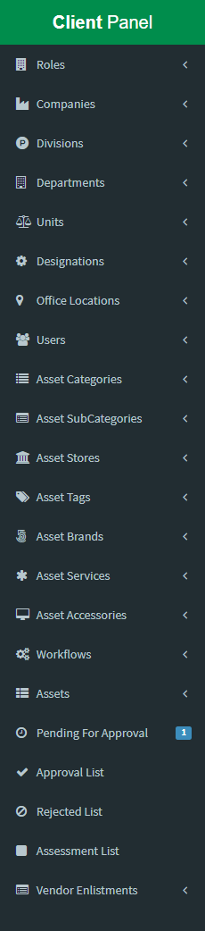**Welcome To Asset Management System**

**Options / Menu Lists:** There are lots of menu in our asset management system software. These are:

1. Roles
2. Companies
3. Divisions
4. Departments
5. Units
6. Designations
7. Office Locations
8. Users
9. Asset Categories
10. Asset Subcategories
11. Asset Stores
12. Asset Tags
13. Asset Brands
14. Asset Services
15. Asset Accessories
16. Workflows
17. Assets
18. Pending For Approval
19. Approval List
20. Rejected List
21. Assessment List
22. Vendor Enlistments

**Lets we discuss about above option step by step….**

**1. Roles: Role is responsible for user access and permission to a specific user to your company asset or apps menu**

* In the menu lists the first option is **Roles**. By default when a client is enrolled our package he/she get an **admin** role. This is not edit or delete.
* By the way client can create / edit / delete his own role except admin role.
* 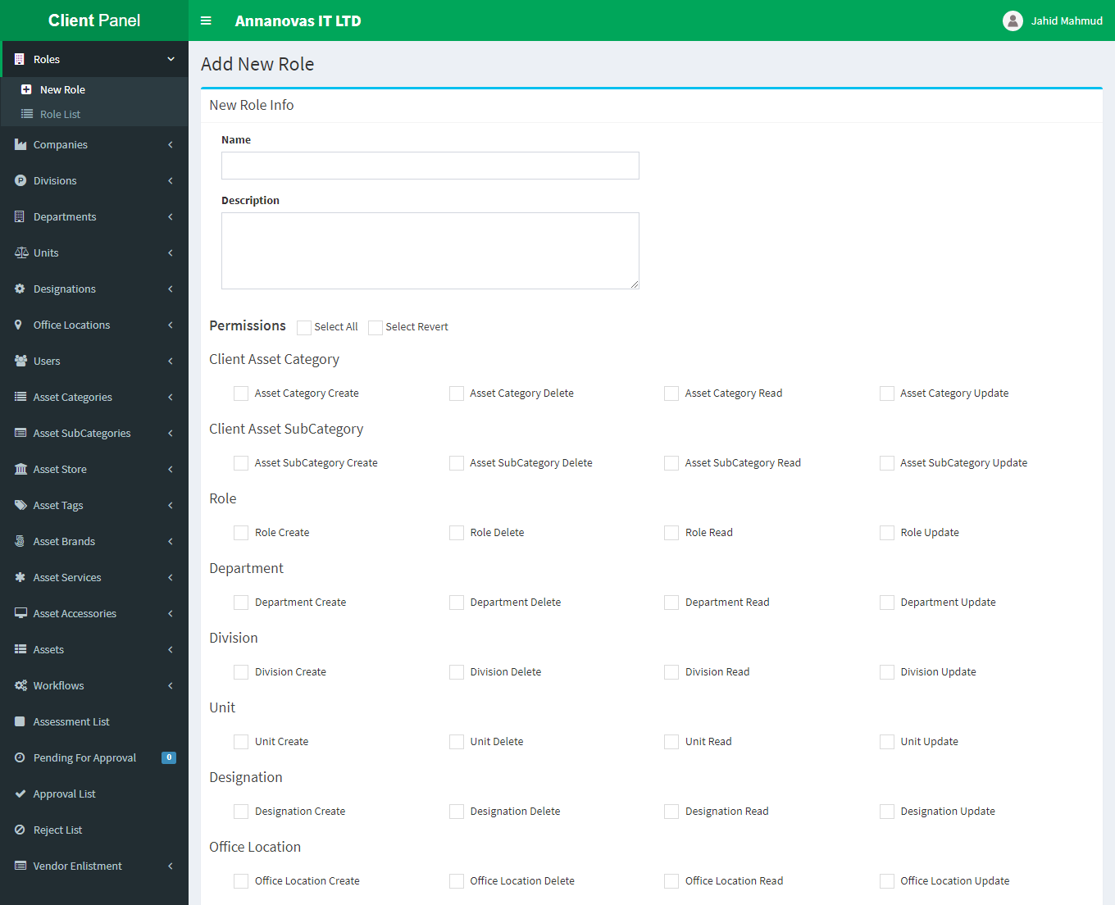To create a role go to Roles => New Role then create your own new role
* From this option you should input name, description and checked permissions which you want to include into this role. Then submit
* After successfully created a role you can see your newly created role from the Role List dropdown menu under Roles.
* 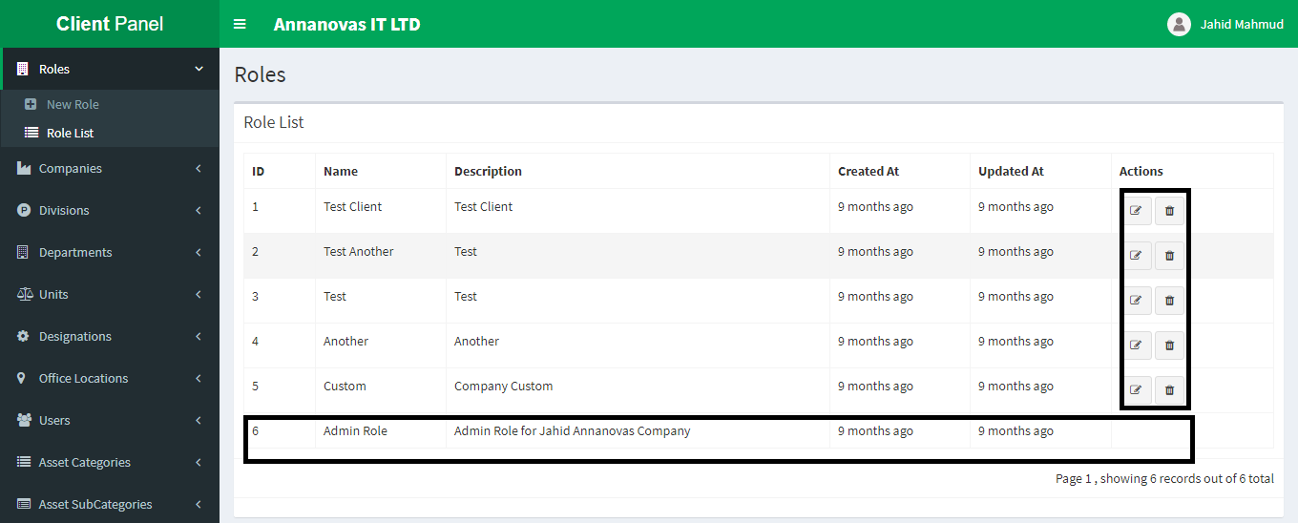From the list you can see that you have only permission to edit or delete from id 1-5 but you can’t delete id number 6.

**2. Companies: Companies menu is responsible for creating multiple companies. Suppose client have multiple companies like group of companies then you can use this menu to create your company.**

* 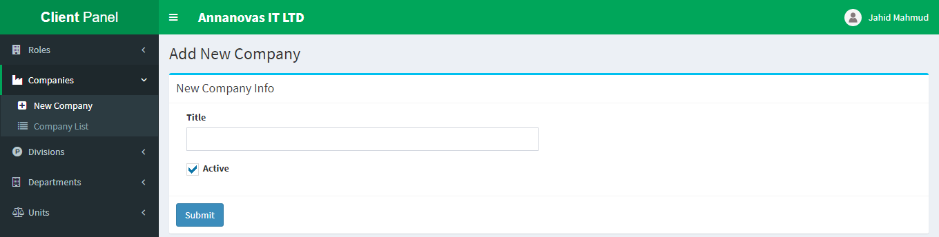To create a new company please navigate to Companies => New Company
* 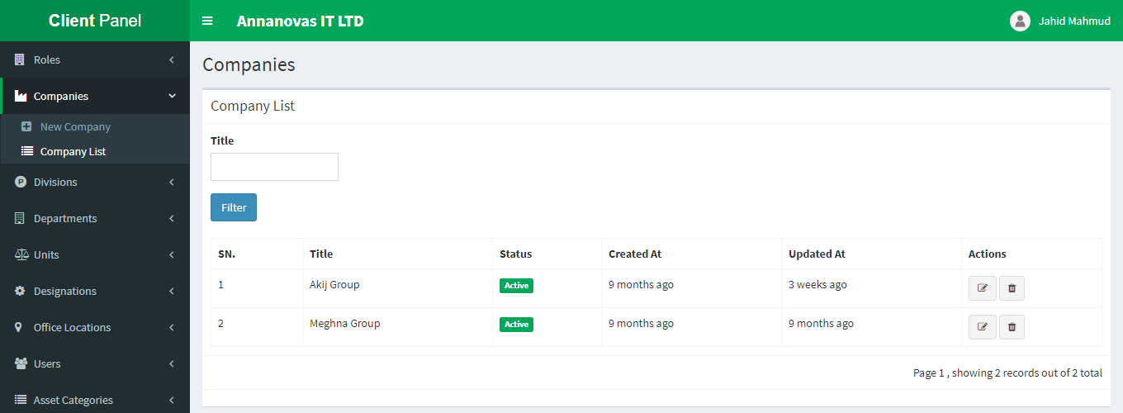After successfully created a company you can see your newly created company from the Company List dropdown menu under Companies.
* From the Company list you can edit or delete your company.

**3. Divisions: Divisions menu is responsible for creating company division like Management division, marketing division etc.**

* 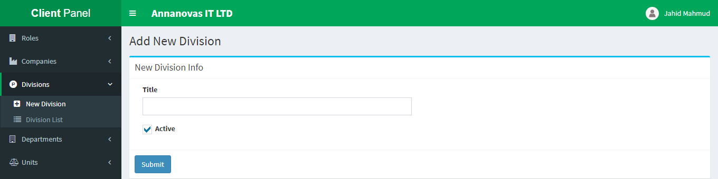To create a new company division please navigate to Divisions => New Division
* After successfully created a division you can see your newly created division from the Division List dropdown menu under Divisions.
* 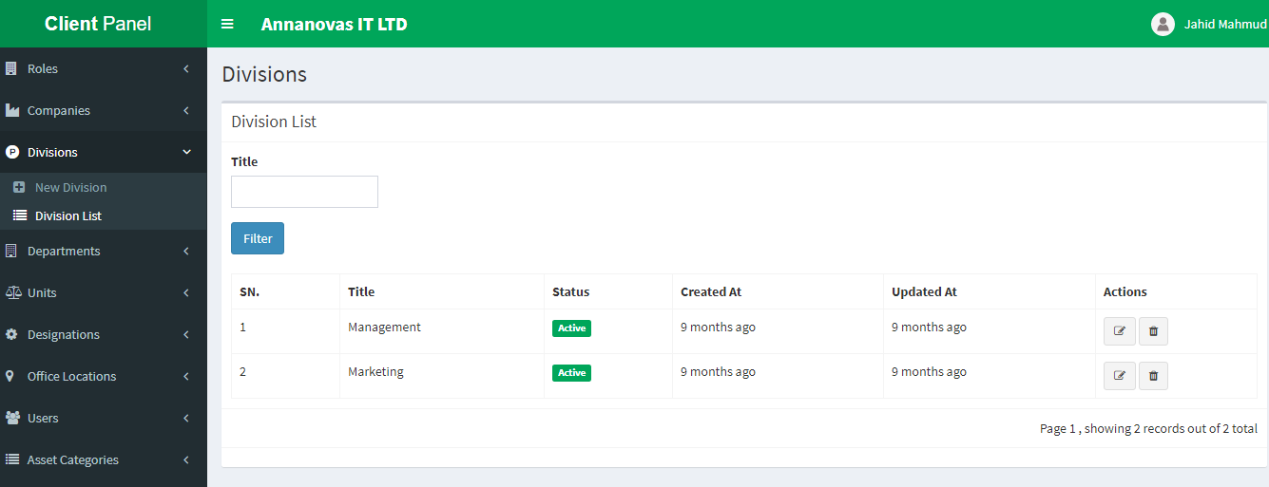From the Division List you can easily edit or delete your newly created division.

**4. Departments: Departments menu is responsible for creating company department like HR department, marketing department etc.**

* To create a new company Department please navigate to Departments => New Department dropdown

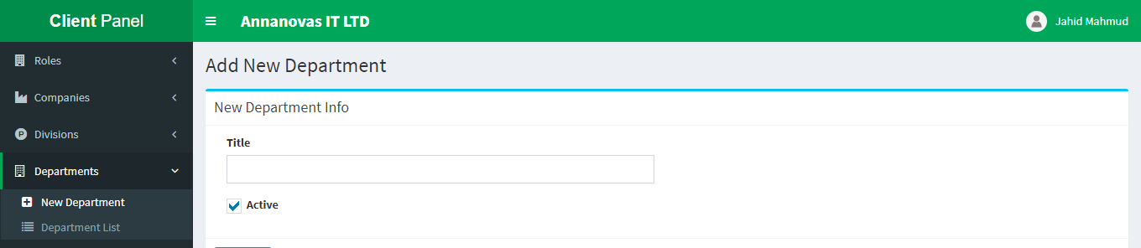

* 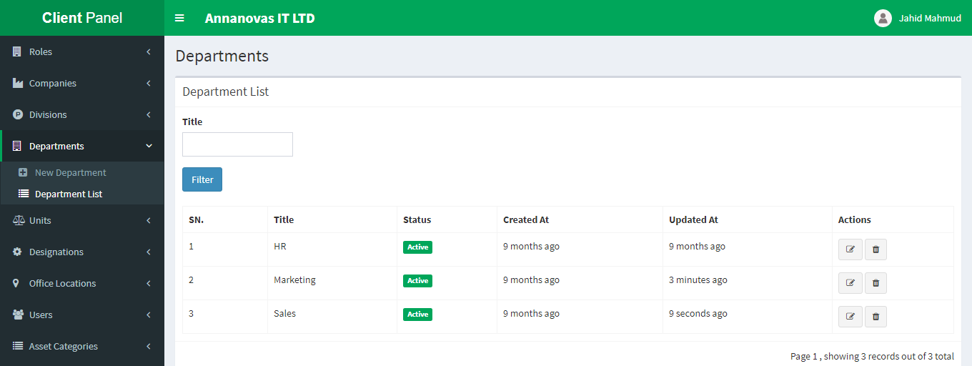After successfully created a department you can see your newly created department from the Department List dropdown menu under Departments.
* From the Department List you can easily edit or delete your newly created department.

**5. Units: Units menu is responsible for creating company unit like Android, IOS, Web units etc.**

* 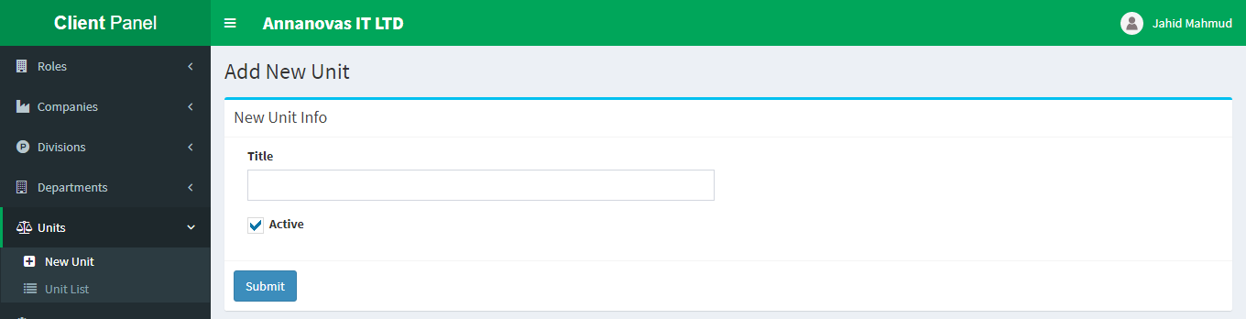To create a new company Unit please navigate to Units => New Unit dropdown
* After successfully created a unit you can see your newly created unit from the Unit List dropdown menu under Units.
* 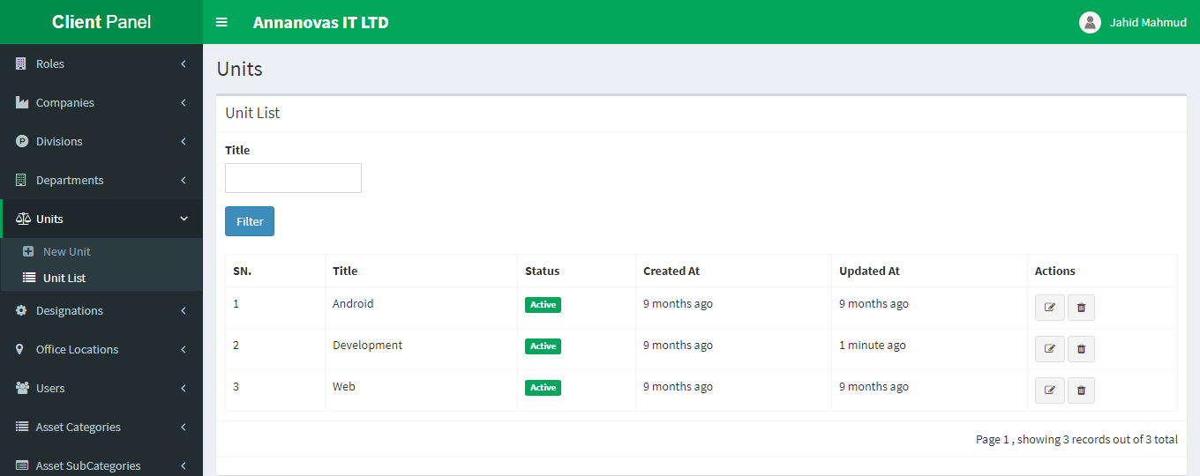 From the Unit List you can easily edit or delete as well as change status of the newly created unit.

**6. Designations: Designations menu is responsible for creating company designation like designer, developer, marketer etc.**

* 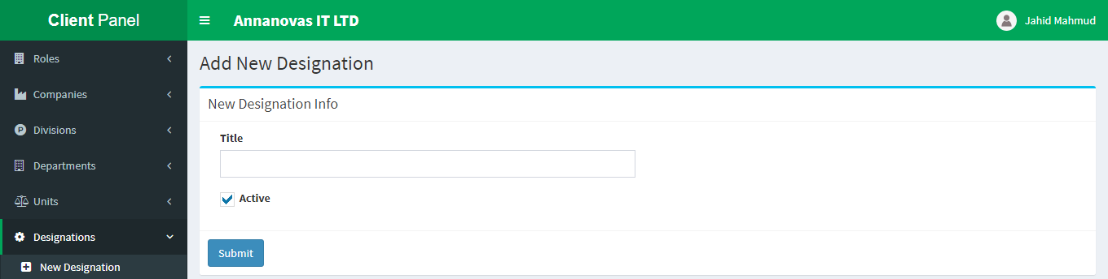To create a new company Designation please navigate to Designations => New Designation dropdown
* 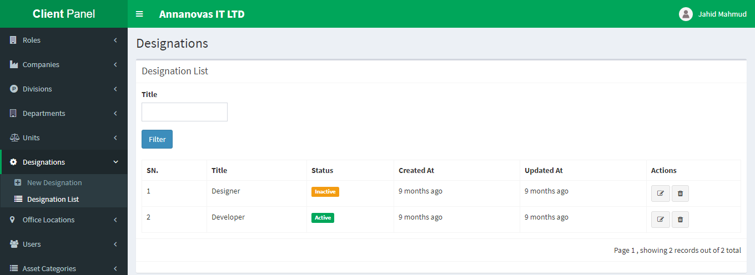After successfully created a designation you can see your newly created designation from the Designation List dropdown menu under Designations.
* From the Designation List you can easily edit or delete as well as change status of the newly created designation.

**7. Office Locations: Office Locations menu is responsible for creating company office location like Dhaka, Rajshahi, and Mirpur etc.**

* To create a new company Office Location please navigate to Office Locations => New Office Location dropdown

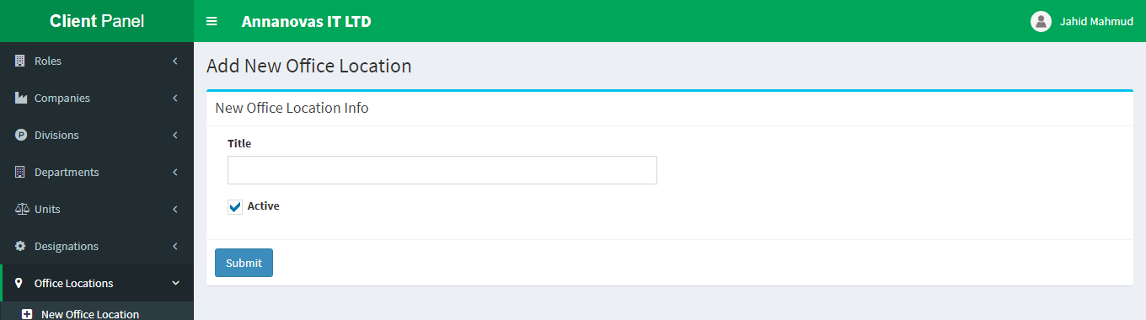

* 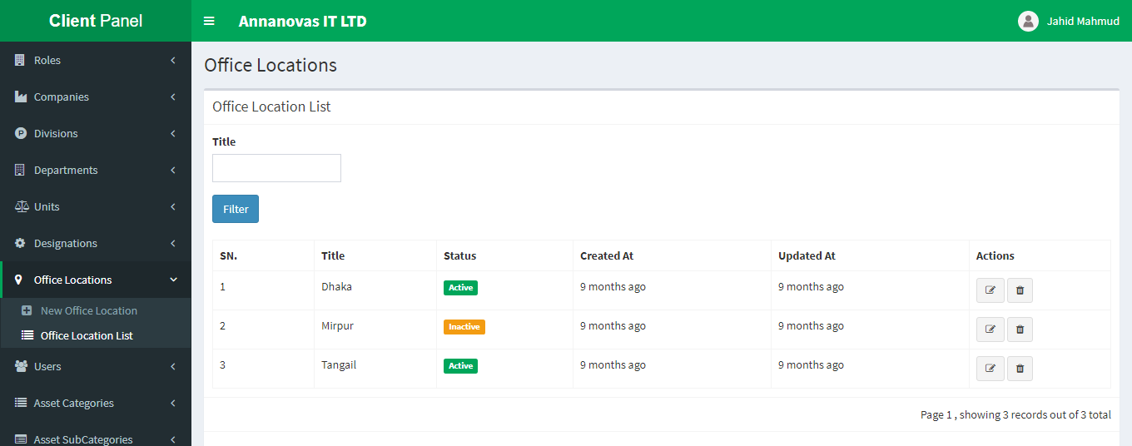After successfully created an office location you can see your newly created office location from the Office Location List dropdown menu under Office Locations.
* From the Office Location List you can easily edit or delete as well as change status of the newly created office location.

**8. Users: Users menu is responsible for creating company employer user account.**

**NB: To create a user account at first full fill the above 1 – 7 steps (if you not have yet) otherwise you can’t create any user.**

* 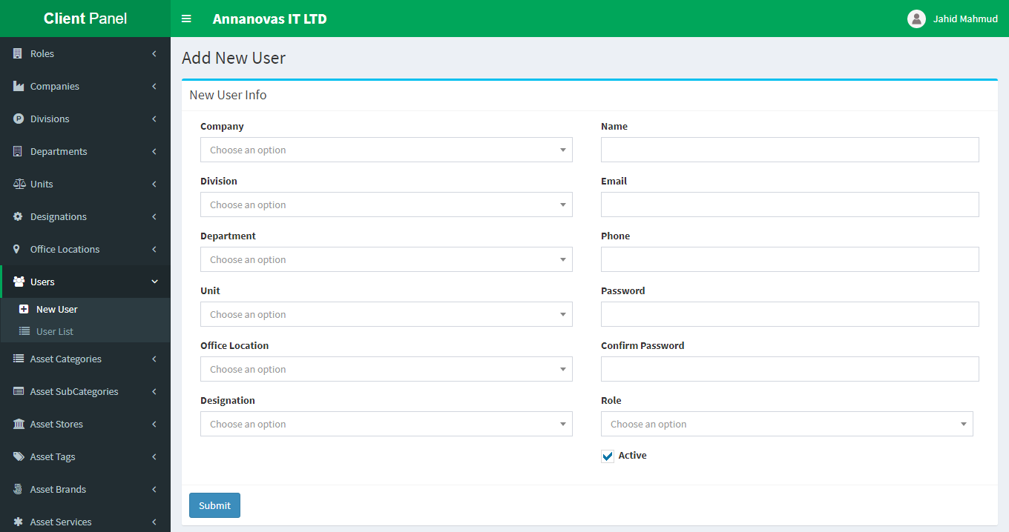To create a new company employee user please navigate to Users => New User dropdown
* To create a user at first creates a company, division, department, unit, office location, designation. If you want to assign custom role except admin role then you create also role first.
* 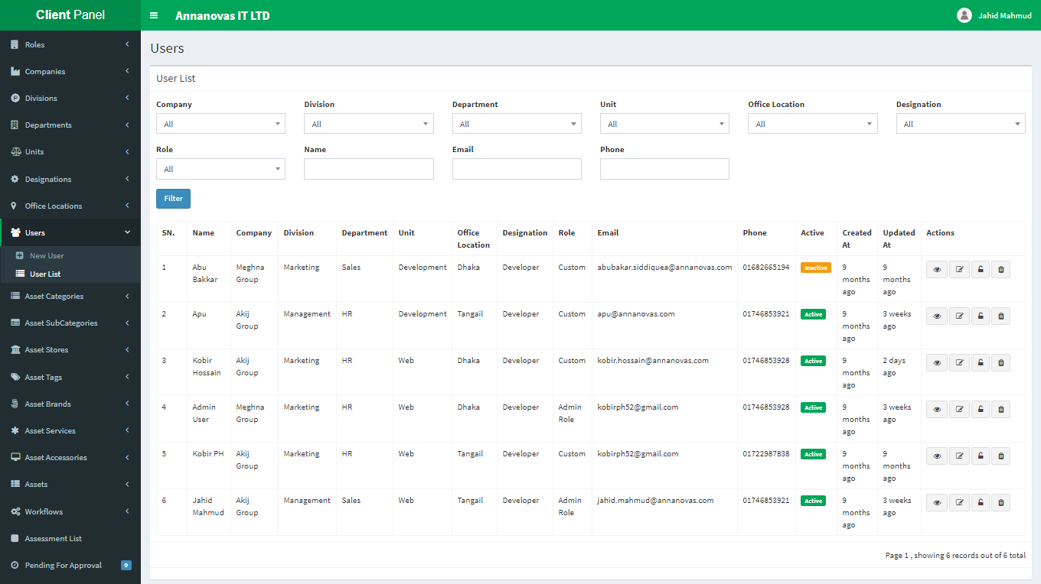After successfully create a user you can see your newly created employee user in the User List dropdown menu under Users.
* 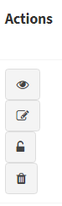From the user list in the Actions column there are four icons (from top to bottom)which responsible
  1. 1st icon(eye) for view the user details
  2. 2nd (edit) for edit the user
  3. 3rd (lock) for change the password
  4. 4th for delete
* To do any action you must have permission for this task otherwise you can’t.
* You can’t delete your own account but uncertainly if deleted all user account you must have contact with software admin to create or update your account again.
* 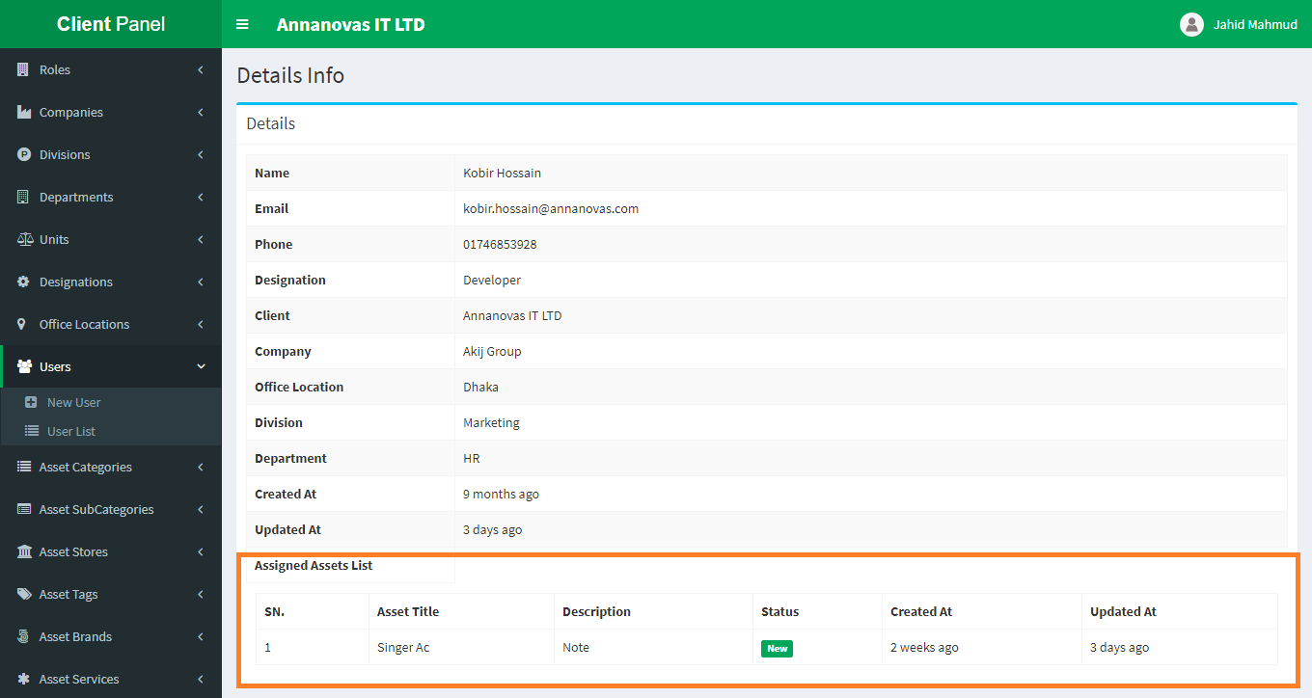From the user detail (eye icon) you can see the details of that specific user as well as you can see how many assets are assign to that user.

**9. Asset Categories: Asset Categories menu is responsible for creating different type of asset category.**

* To create a new company asset category please navigate to Asset Categories  => New Category
* 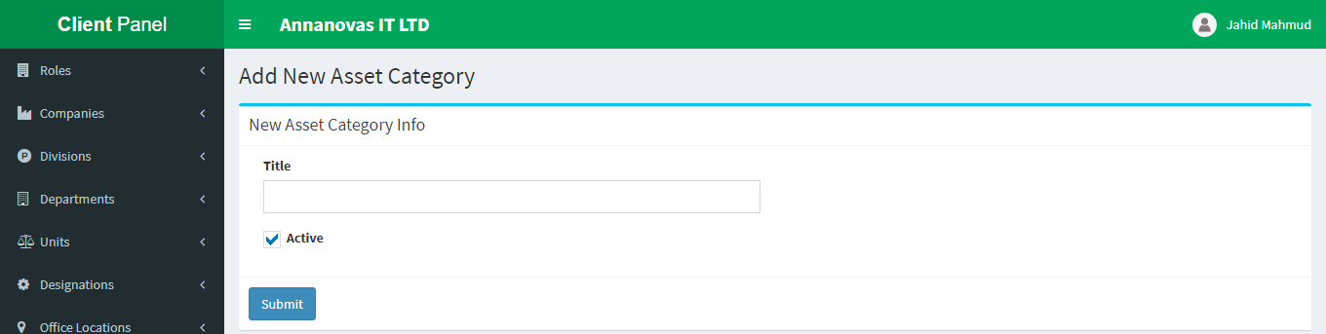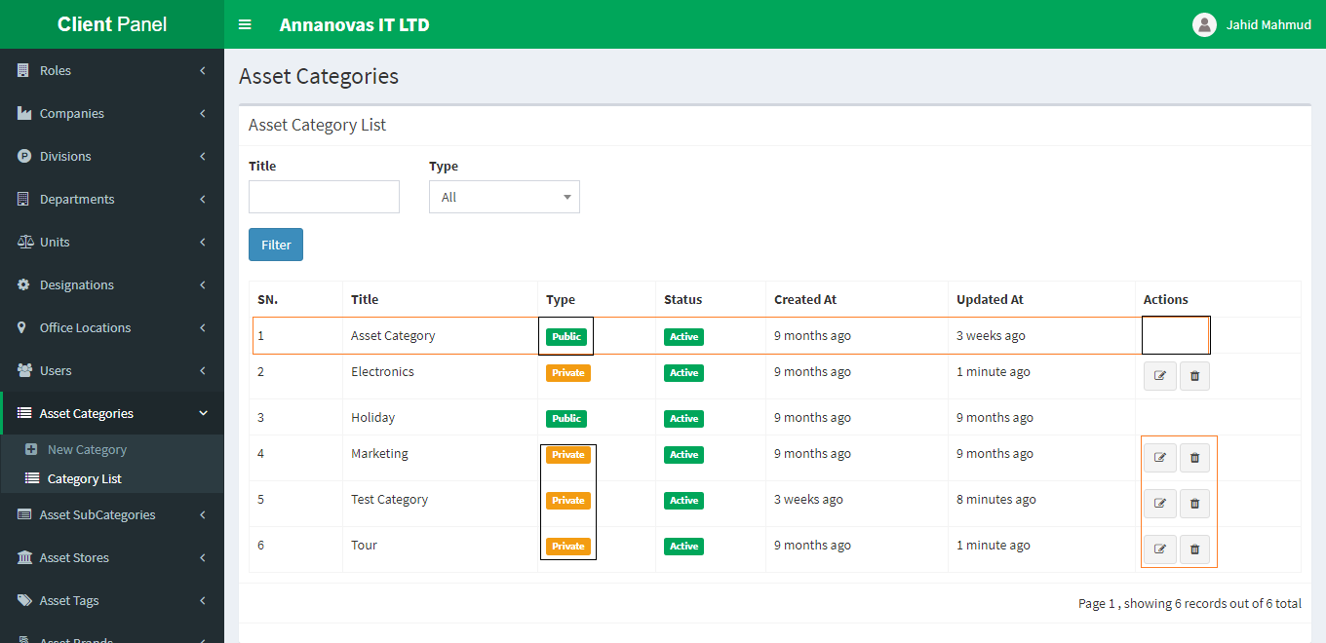After successfully create a category you can see your newly created category in the Category List dropdown menu under Asset Categories.
* From the above list you can see along the type column there are two options public and private.
* By default when you create a category it will be private and only for your own company that mean this category is only for you. You can edit or delete it.
* Your private category also views the application owner.
* The application supper admin can change your private type category to public for free to use other companies if he thought.
* If the category type is public then you can’t edit/delete your category any more.

**10. Asset SubCategories: Asset SubCategories menu is responsible for creating different type of asset sub category.**

* To create a new company asset sub category please navigate to Asset SubCategories  => New SubCategory
* 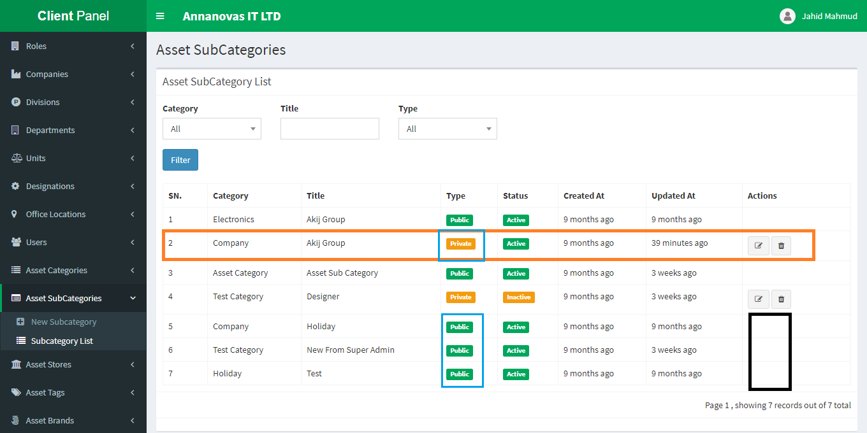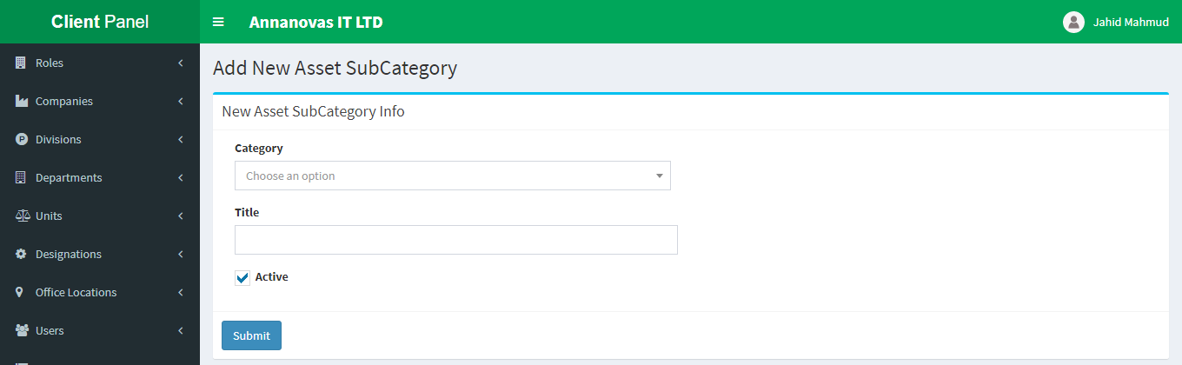After successfully create a sub category you can see your newly created sub category in the SubCategory List dropdown menu under Asset SubCategories
* From the above list you can see along the type column there are two options public and private.
* By default when you create a sub category it will be private and only for your own company that mean this sub category is only for you. You can edit or delete it.
* Your private sub category also views the application owner.
* The application supper admin can change your private type sub category to public for free to use other companies if he thought.
* If the sub category type is public then you can’t edit/delete your sub category any more.

**11. Asset Stores: Asset Stores menu is responsible for creating different type of asset stores.**

**NB: To create a new store you must have company office location first.**

* To create a new company asset store please navigate to Asset Stores => New Store

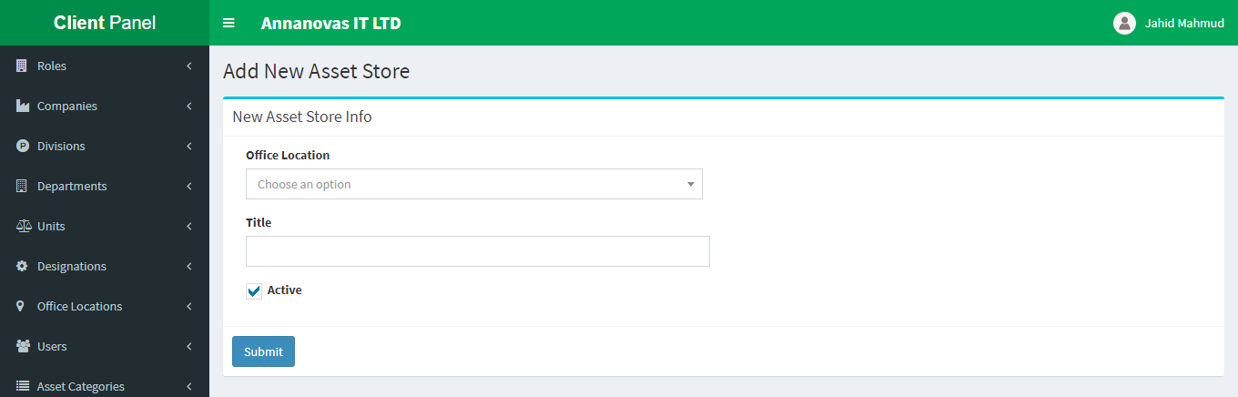

* Create a store you have to select an office location first.
* 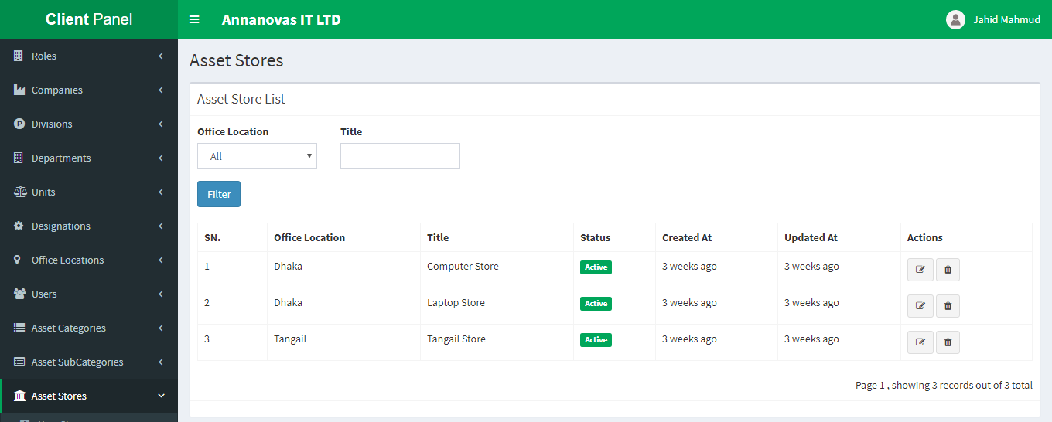After successfully create a store you can see in your newly created store in the Store List dropdown menu under Asset Stores.
* From the Store List you can easily edit or delete as well as change status of the newly created store.

**12. Asset Tags: Asset Tags menu is responsible for creating different type of company asset tags.**

* To create a new company Asset Tag please navigate to Asset Tags => New Tag dropdown

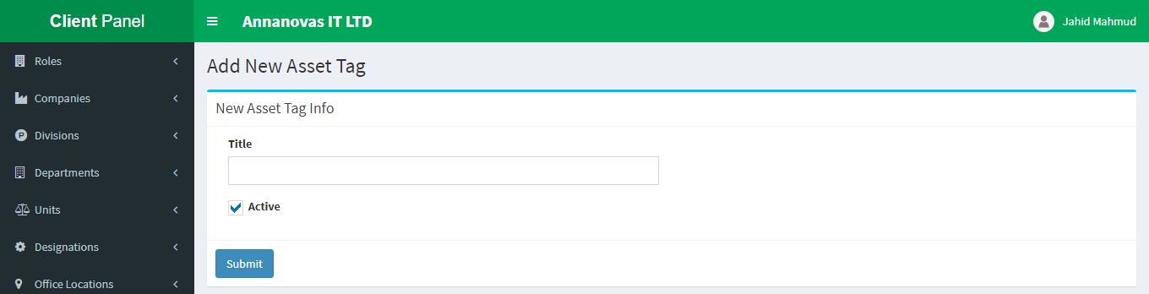

* 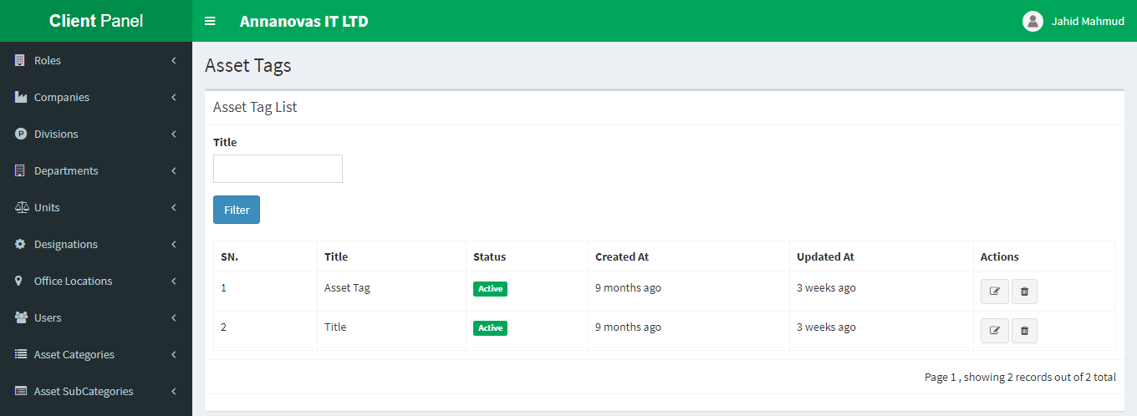After successfully created an asset tag you can see in your newly created tag from the Tag List dropdown menu under Asset Tags.
* From the Tag List you can easily edit or delete as well as change status of the newly created asset tags.

**13. Asset Brands: Asset Brands menu is responsible for creating different type of asset brand name.**

* 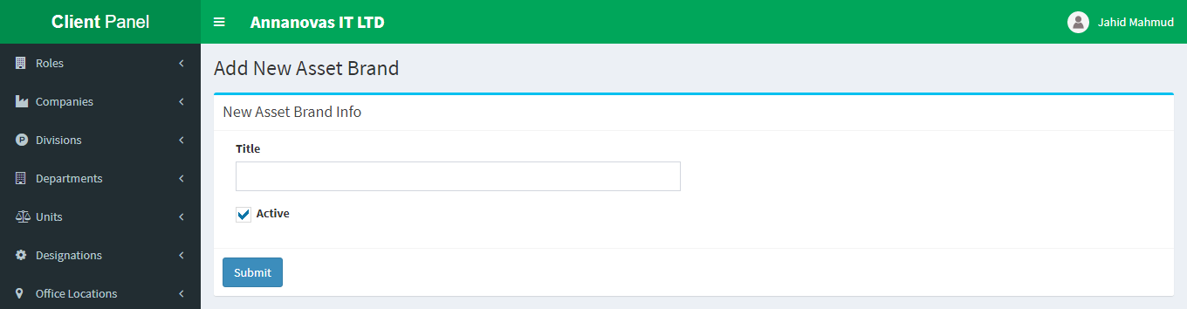To create a new company asset brand please navigate to Asset Brands  => New Brand
* After successfully created an asset brand you can see in your newly created brand from the Brand List dropdown menu under Asset Brands.
* From the below list you can see along the type column there are two options public and private.
* By default when you create a brand it will be private and only for your own company that mean this brand is only for you. You can edit or delete it.
* Your private type brand also views the application owner.
* The application supper admin can change your private type brand to public for free to use other companies if he thought. 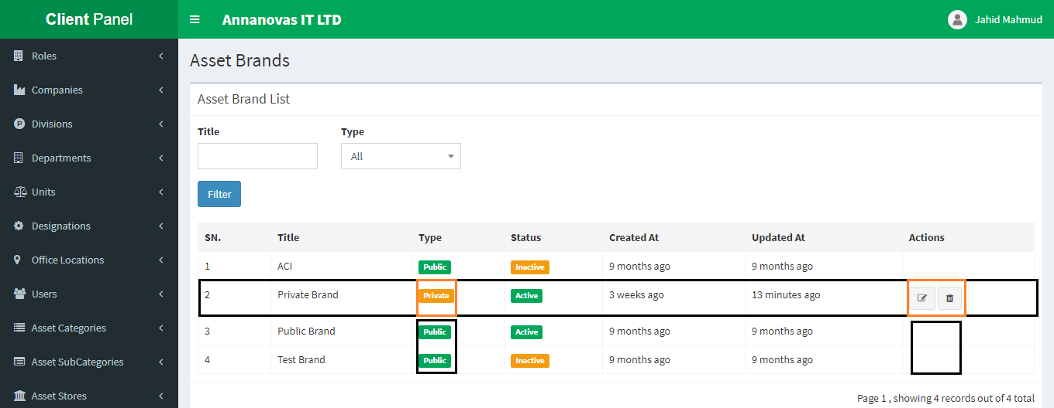
* If the brand type is public then you can’t edit/delete your brand any more.

**14. Asset Services: Asset Services menu is responsible for creating different type of asset service.**

* 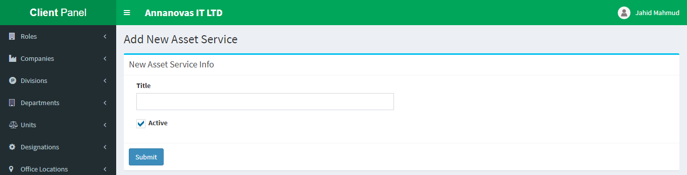To create a new company asset service please navigate to Asset Services  => New Service
* 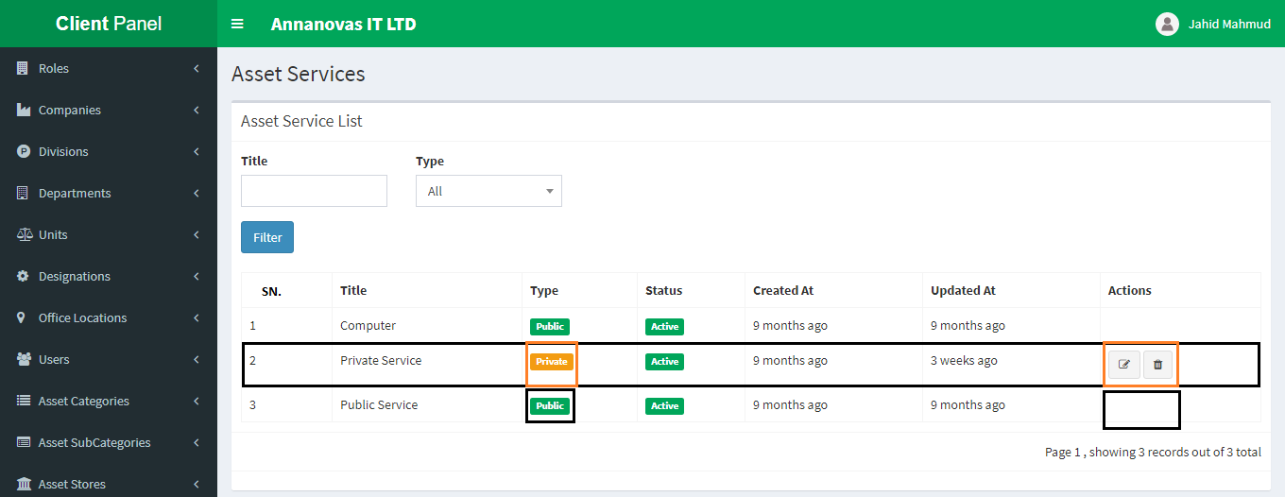After successfully created an asset service you can see in your newly created service from the Service List dropdown menu under Asset Services.
* From the above list you can see along the type column there are two options public and private.
* By default when you create a service it will be private and only for your own company that mean this service is only for you. You can edit or delete it.
* Your private type service also views the application owner.
* The application supper admin can change your private type service to public for free to use other companies if he thought.
* If the service type is public then you can’t edit/delete your service any more.

**15. Asset Accessories: Asset Accessories menu is responsible for creating different type of asset accessory.**

* 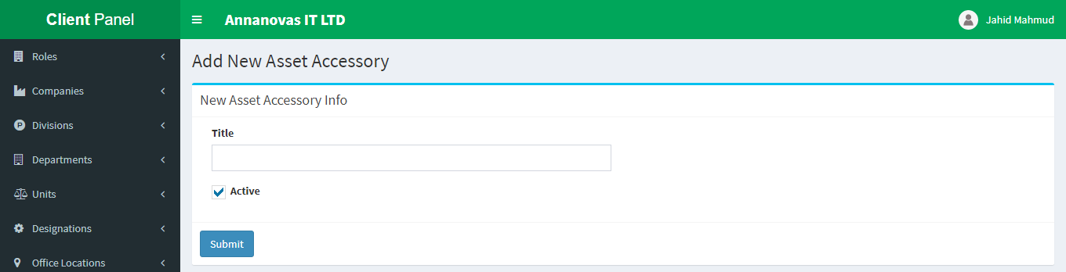To create a new company asset accessory please navigate to Asset Accessories  => New Accessory
* 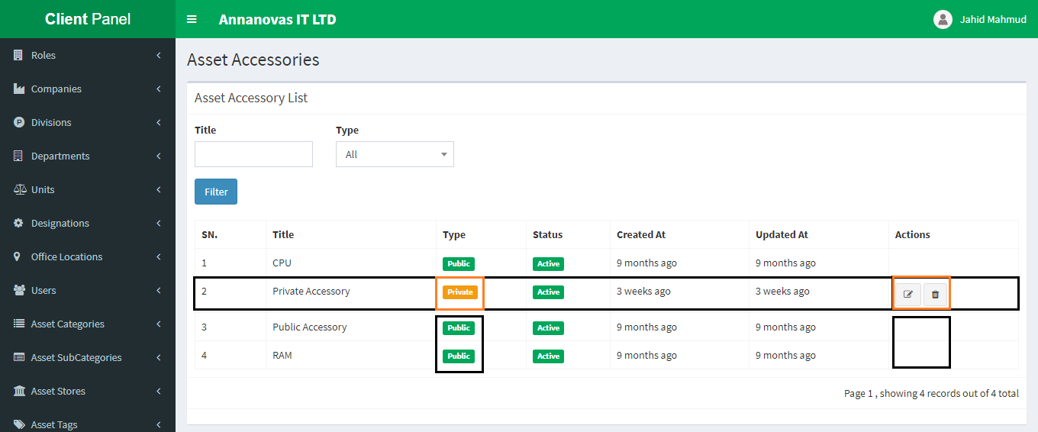After successfully created an asset accessory you can see in your newly created accessory from the Accessory List dropdown menu under Accessories.
* From the above list you can see along the type column there are two options public and private.
* By default when you create an accessory it will be private and only for your own company that mean this accessory is only for you. You can edit or delete it.
* Your private type accessory also views the application owner.
* The application supper admin can change your private type accessory to public for free to use other companies if he thought.
* If the accessory type is public then you can’t edit/delete your accessory any more.

**16. Workflows: Workflows menu is responsible for creating different type of asset workflows.**

* Asset workflow is very important feature for asset management application. When an asset has any defect in run time, it needs to be repair to re-use it. For repairing this defected asset, it needs permission from boss or other senior officer. This option is responsible for that purposes. When enlist an asset you have to assign a workflow / select a workflow for which user will permit when this asset is defect.
* 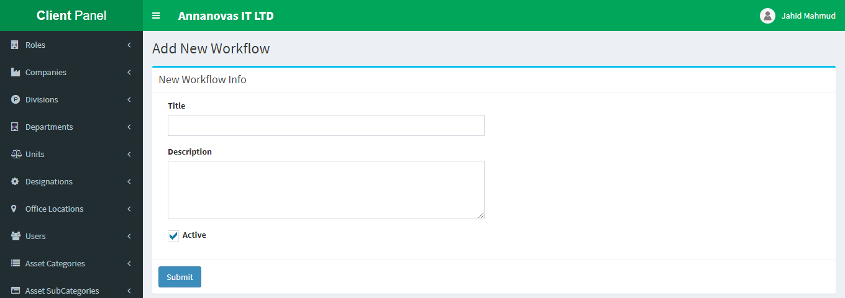To create a new workflow please navigate to Workflows  => New Workflow
* After successfully created an asset workflow you can see in your newly created workflow from the Workflow List dropdown menu under Workflows.
* 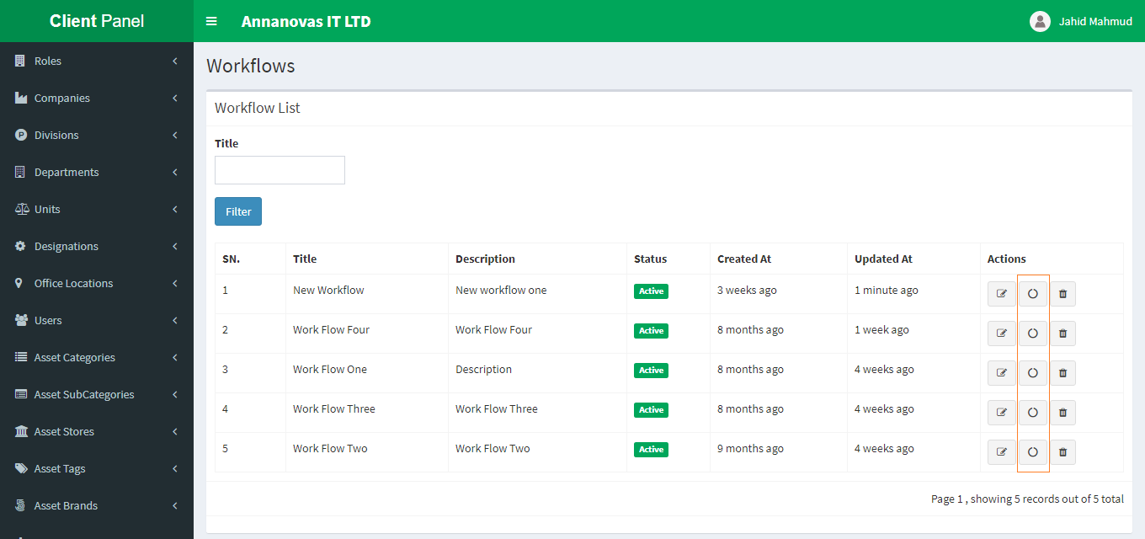From the above list you can see along in the actions column there are three options(icons) 1st icon responsible for edit the existing workflow , 3rd icon is responsible for delete and finally the 2nd (marked) is responsible for create workflow process.
* 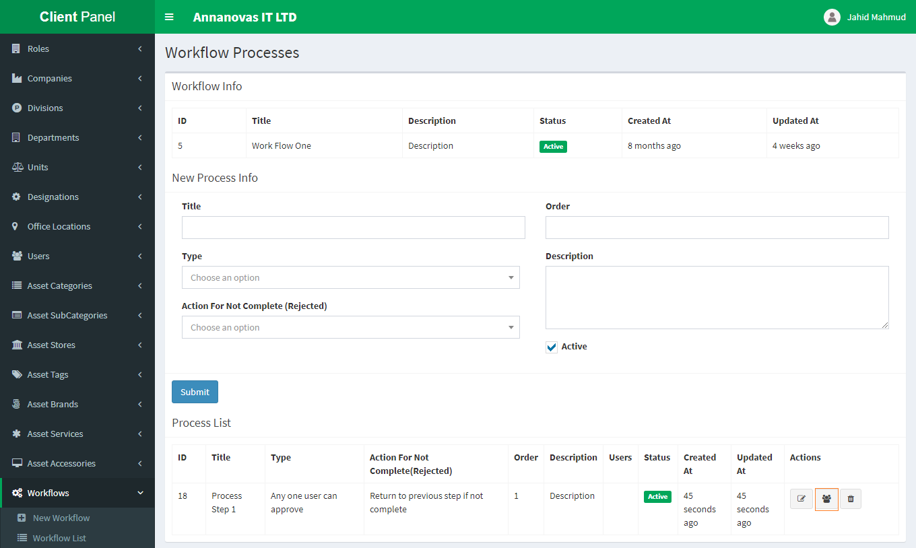Workflow Process is that where you can add how many process steps is responsible for this workflow. If you click the middle icon then you can see
* From the above figure you can see that there are different type of input fields where title for process title. In the **Type** select box you can see Tree different options   
   1st => 'Any one user can approve',  
   2nd => 'All of the user must approve',  
   3rd => 'Minimum no. of user can approve'
* **1st => 'Any one user can approve':** This mean the current process is approved by which how many users. Suppose the current process have three users(we show next how to assign user in this current process) then if you select this option then when any user can approve then the process is end and new process in start if have.
* **2nd => 'All of the user must approve':** This mean the current process will be end or go to the next step (if have) when the all of assign user will approve.
* **3rd => 'Minimum no. of user can approve':** If you select this option then another field is appear where you input minimum number of users is required. Suppose you assign three users and you select 3rd option and input 2 then if two users are approved among the three users then process go to the next step.

**Action for Not Complete (Rejected):** If any one of above three type is not fulfilled then which action will be done you can defined by this select box. It also three options:

1st => 'Return to previous step if not complete',   
2nd => 'Proceed to next step',

3rd => 'Stop'

* **1st =>** '**Return to previous step if not complete':** This mean if any option of Type field is not complete and if you select in conjunction with '**Return to previous step if not complete'** then process return to previous step.
* **2nd => 'Proceed to next step':** This mean if any option of Type field is not complete and if you select in conjunction with **'Proceed to next step '** then process go to next step.
* **3rd => 'Stop':** If you select this option in conjunction with Type option the whole process will be stopped.
* There another input field is **order** responsible for which process is start after first one. Order should be positive integer number like 1, 2, 3…
* 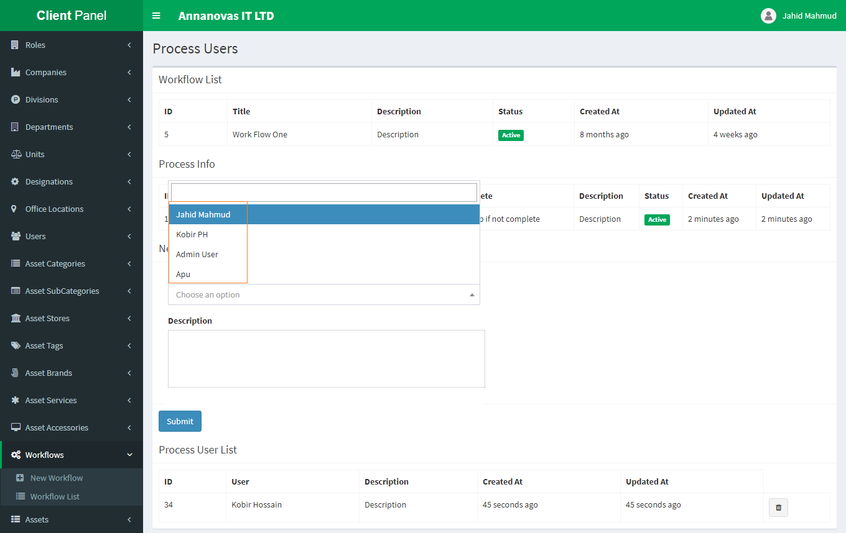In the bottom you can see your entire process list. You can add multiple processes which you need. In the list actions column you can see a mark user’s icon which is responsible for assign process user. If you click the icon then

This page is appearing where a select input option, where all of company users / employers list are shown.

* From here you can assign your required users.
* You can also remove user from here.
* Another Important notice is that when an asset requested for repairing by any permitted vendor then you cannot edit or remove corresponding workflow and a warning is appear in the top of that workflow like the following image billow

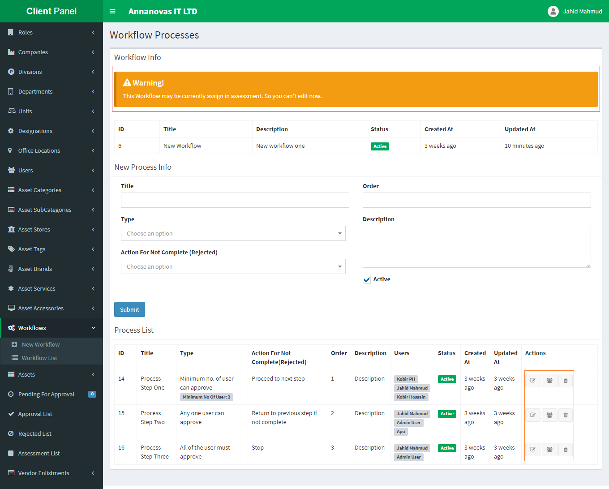

**17. Assets: Assets menu is responsible for creating different type of assets.**

**NB: To enlist an asset you must have full field 1-16 steps first otherwise there an error will be occurred.**

* The center feature of our asset management application is asset enlistment. If you completed above 1-16 tasks/ guides then you are ready to listing your company assets into our application.
* To create a new company asset please navigate to Assets  => New asset
* 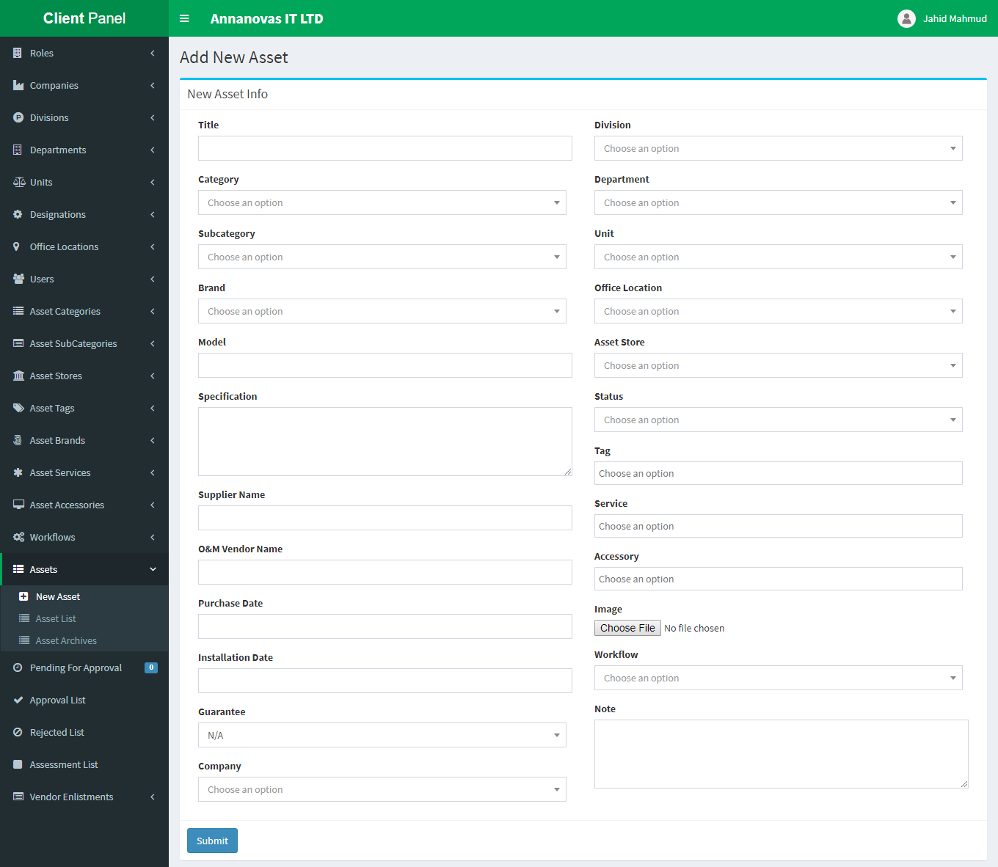 After successfully created an asset you can see in your newly created asset from the Asset List dropdown menu under Assets.  
  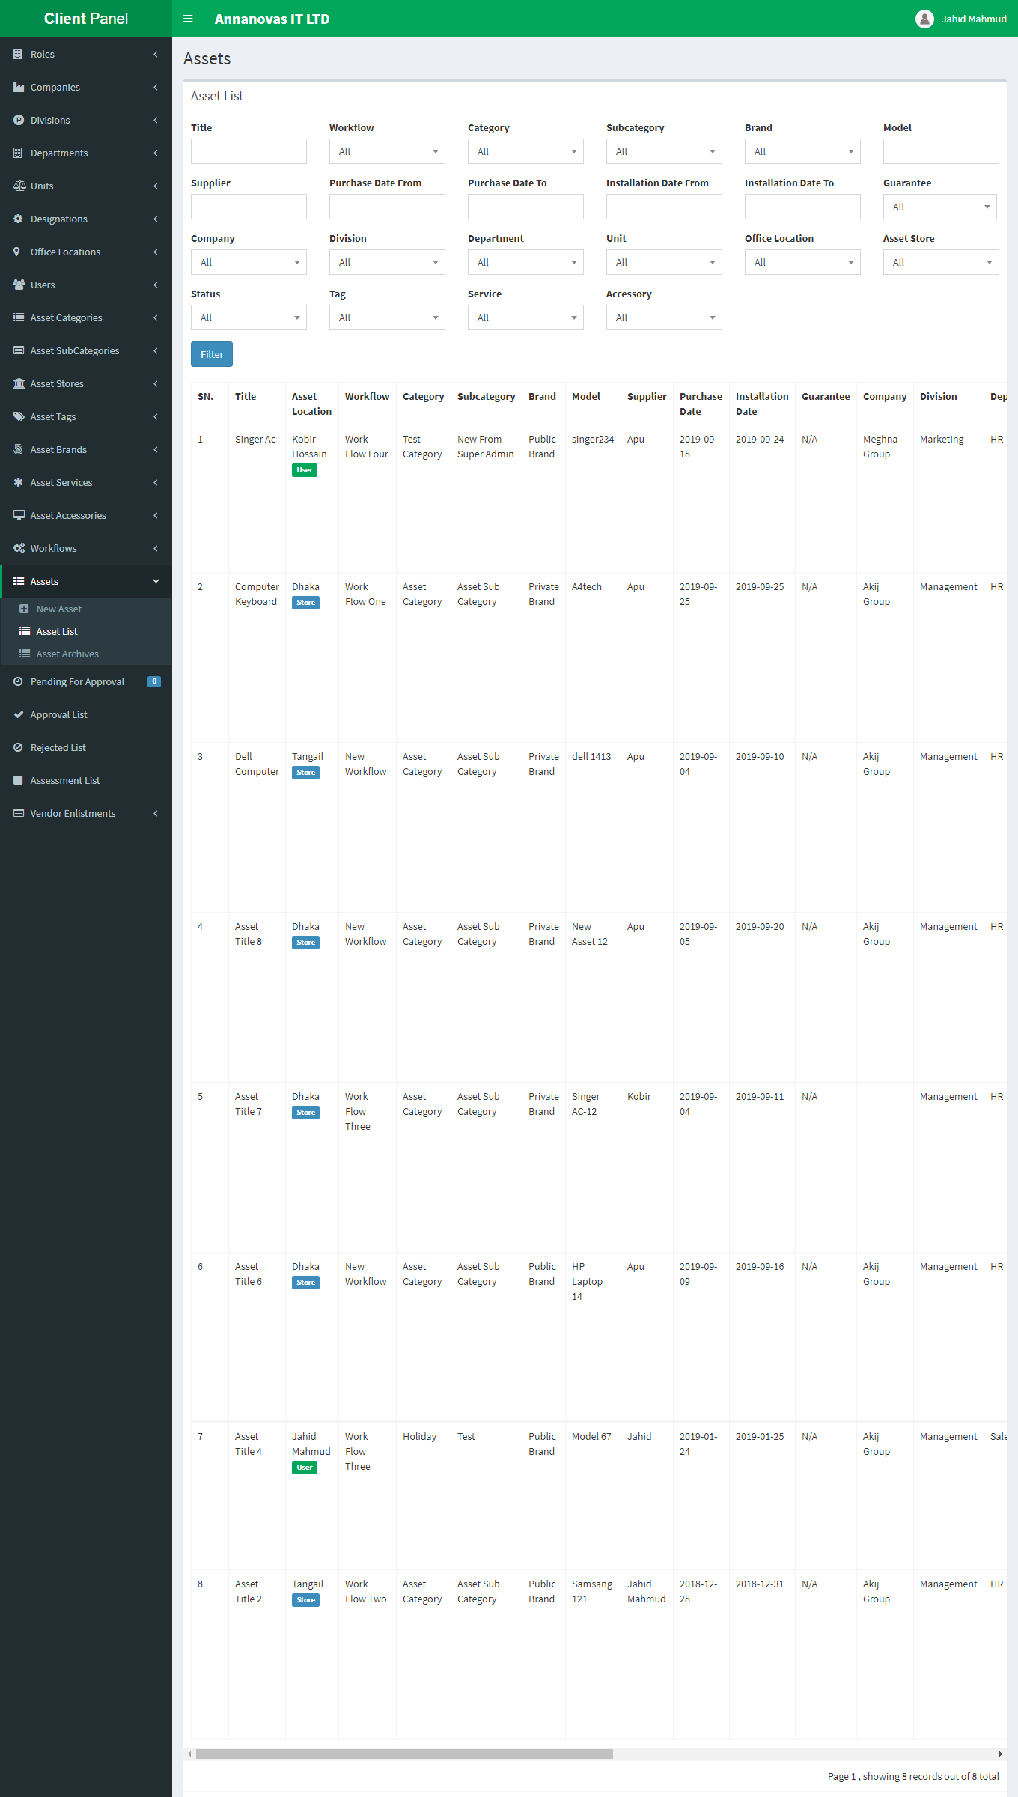
* From the above asset list there are lots of options along the actions column. From top to bottom

assets-actions-icon.png

1. 1st icon(eye) for view the asset details
2. 2nd (edit) for edit the asset
3. 3rd (file) for asset file attachment
4. 4th (user plus) for asset assign to user
5. 5th (trash) for delete
6. 6th (book) all logs of that asset
7. 7th (lock) for asset permission for vendor

* To do any action you must have permission for this task otherwise you can’t.

**1st icon (eye):** By clicking this icon you can see all details if this asset.

**2nd (edit):** By clicking this icon you can edit the asset data. Also move this asset to archive list.

**3rd (file):** By clicking this icon you can add different type of attachment file.

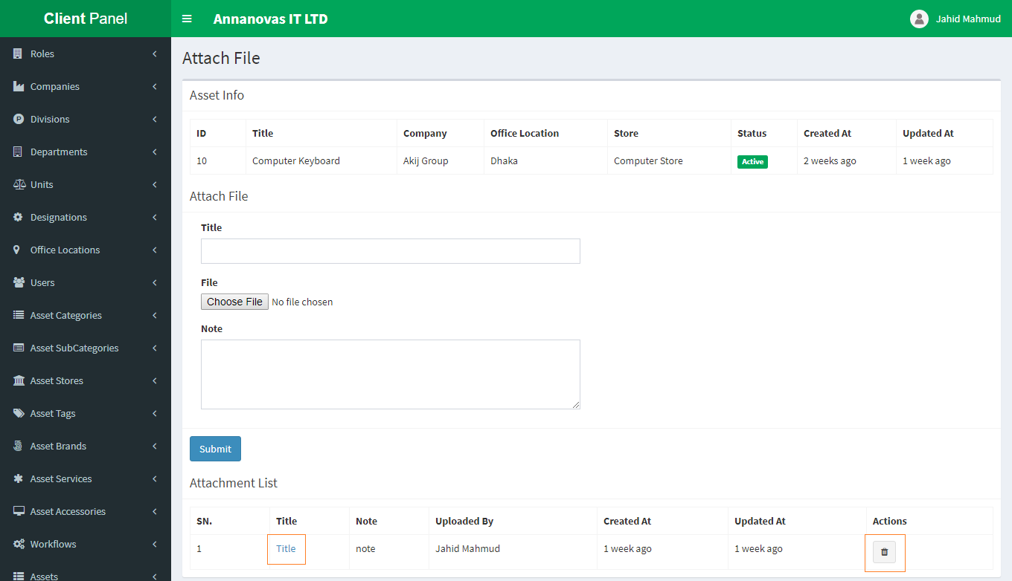

From above you can see all of attachment list. You can view attachment by clicking title or you can also remove any previously attached file.

**4th (user plus):** By clicking this icon you can assign asset to a user if it available in the store room. If the asset is assigned to a user can’t assign anymore unless it return to store. You can assign user according to asset store location.

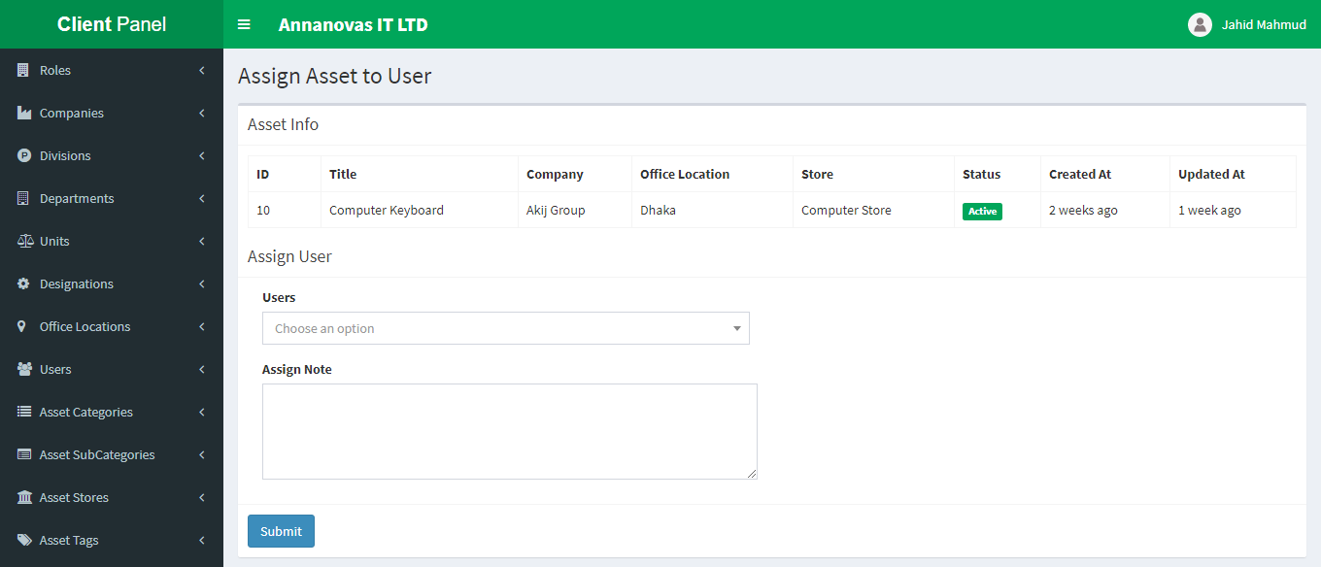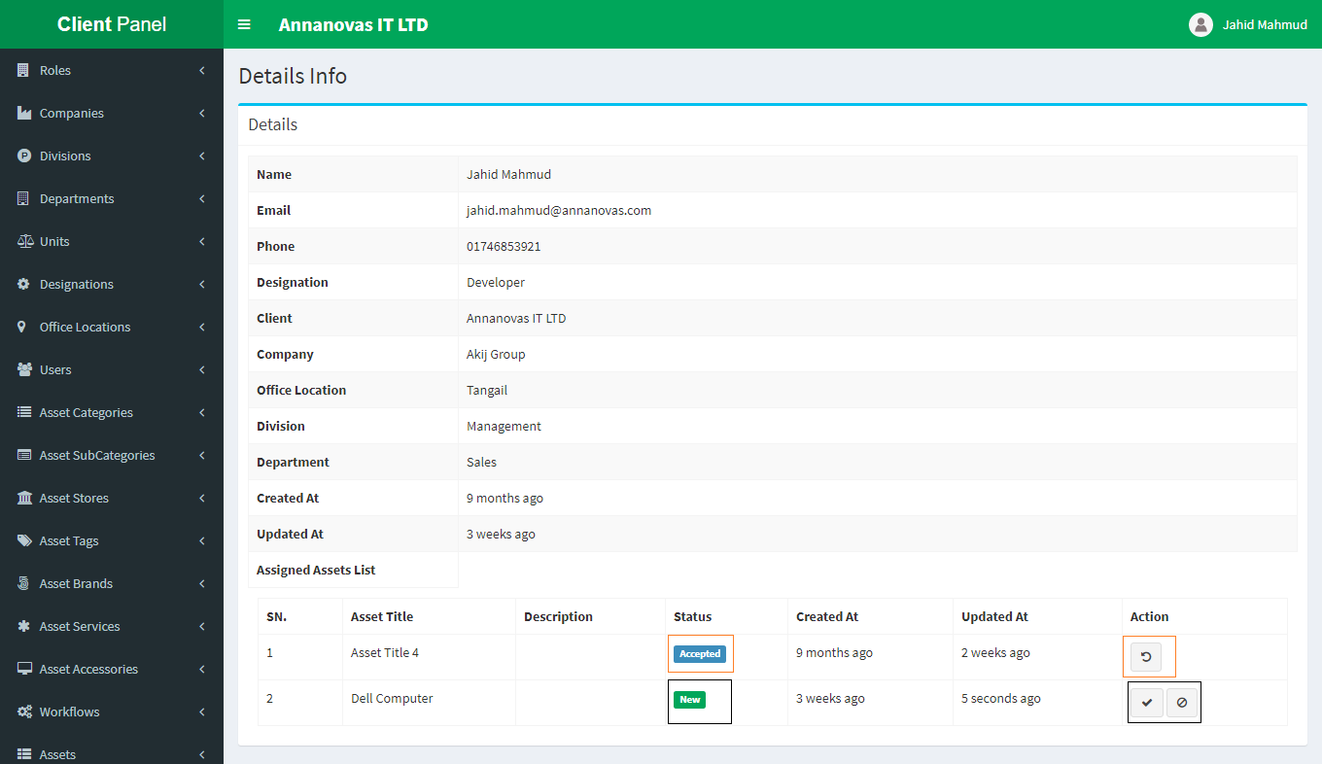When an asset is assigned to a user the user can see it from his/her profile details.

From the profile details asset assigned to you. From the status column you can see which asset is newly assigned. If the asset is newly assigned then you can accept or reject it. If you reject any asset then you must have insert a note why you reject it.

If you accept asset previous then you can return it to store any time then it preview by the administrator why you return that asset.

**5th (trash):** By clicking this icon you can delete this asset.

**6th (book):** By clicking this icon you can see all logs of that asset

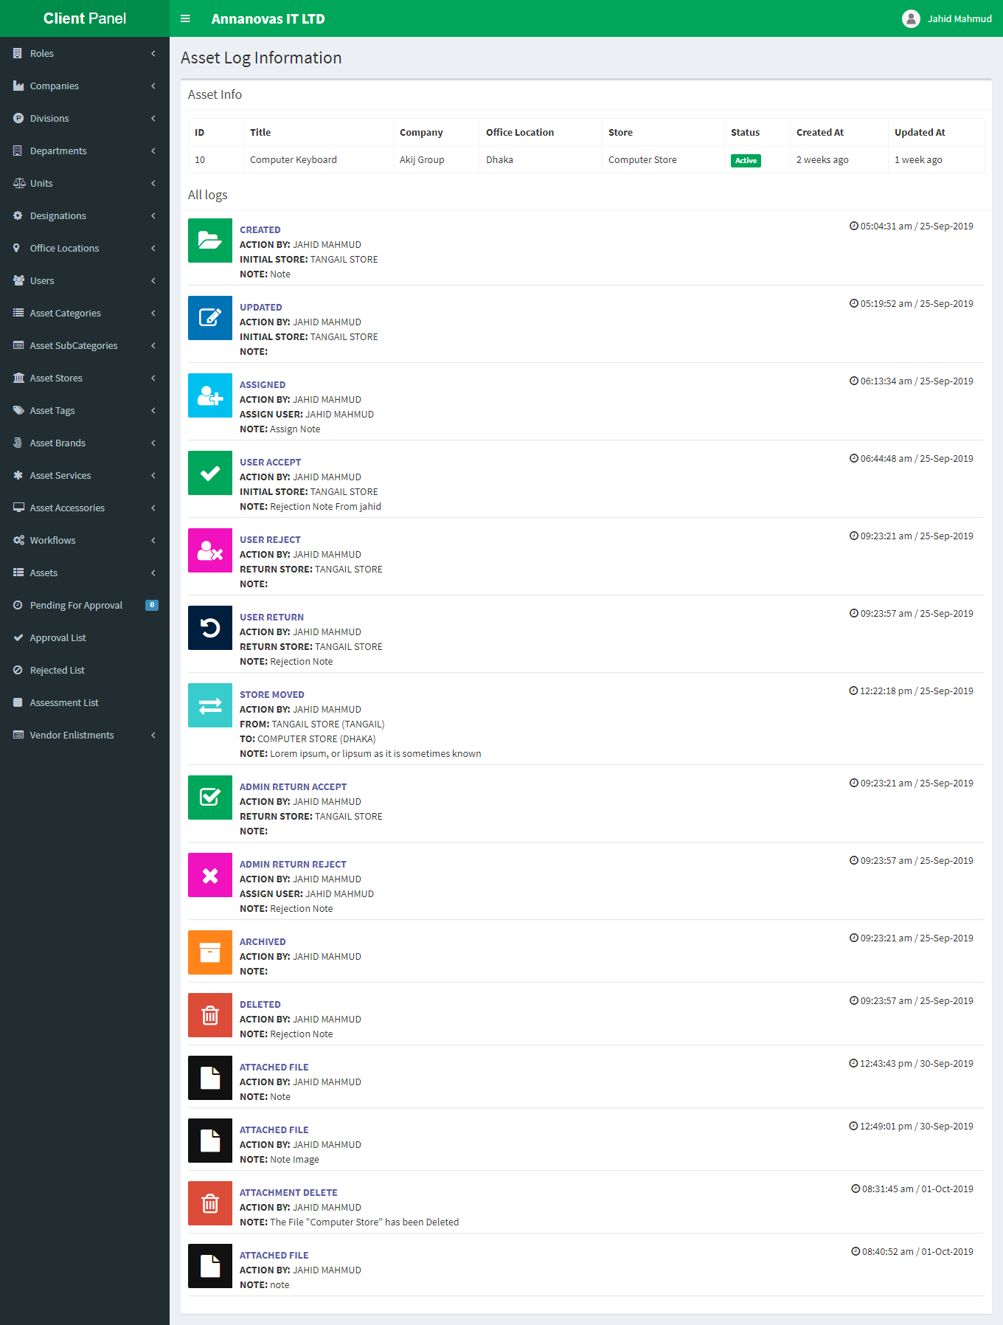g. 7th **(lock):** By clicking this icon you can permission to the vendor which your company enlisted (how 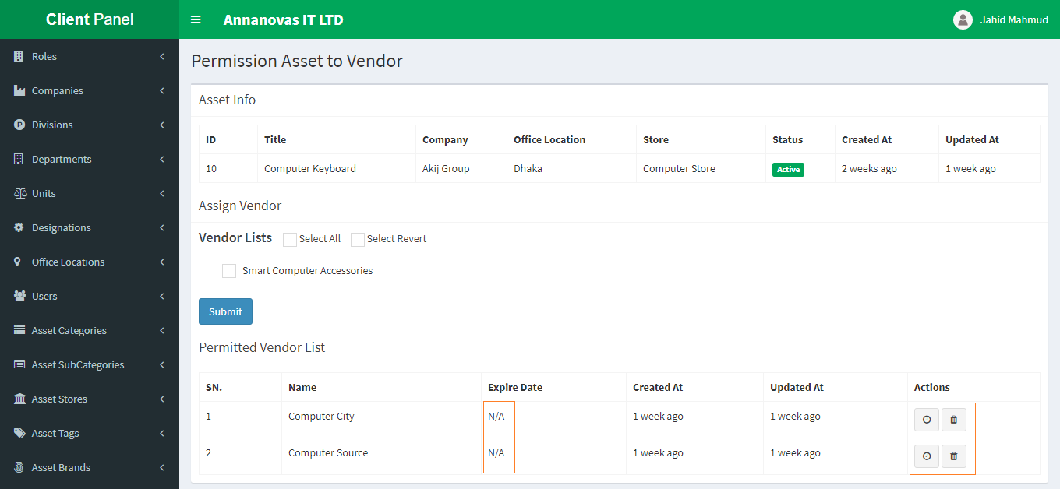to enlist a vendor we show next) for asset permission.

All enlisted vendors are shown in here then you can permission this asset to the vendor which you want. You can permit asset to multiple vendors at a time. You can remove previous vendor permission. By default there are no expire date. You can also set specific time.

**18. Pending For Approval: Pending For Approval is responsible for viewing asset approval pending list.**

* 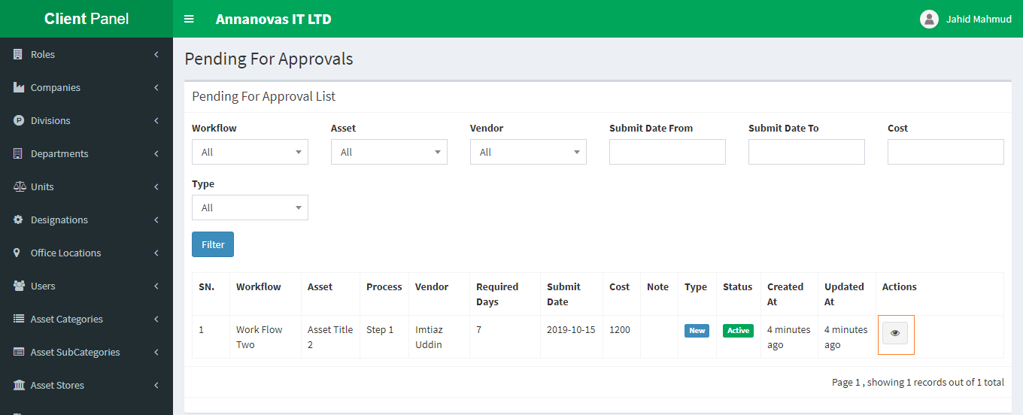When your enlisted vendor creates an assessment (asset repairing request) then you can see your pending list (remember you will only see that pending list if the asset is permitted by you i.e. your name must have that asset workflow)
* 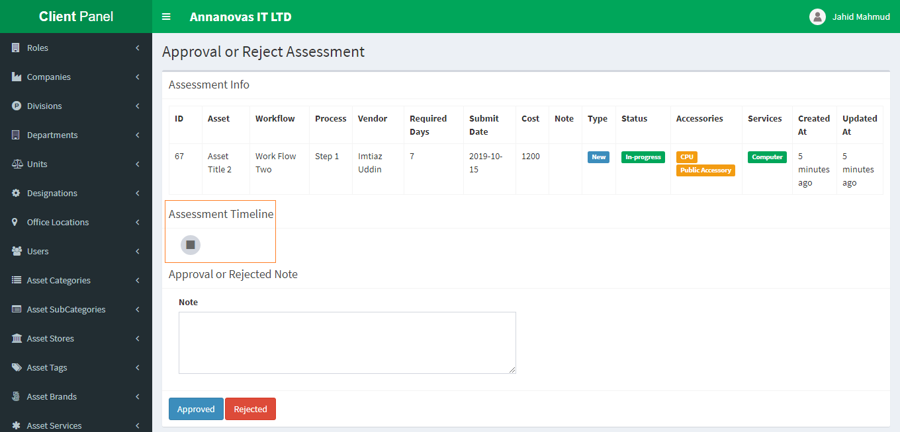From the above pending for approval list you see all details of that assessment like which enlist vendor request it, which workflow responsible for it which process currently running etcetera. By clicking the eye icon you can approve or reject the pending assessment.
* You can also view details from here as well as see assessment timeline too.
* After writing approval or rejection note you can approved or rejected it.
* If you approved it then you see your all approved list from the Approval List menu.
* If you Rejected it then you see your all rejected list from the Rejected List menu.

**19. Approval List: Approval List menu is responsible for viewing all assessment approval lists.**

* 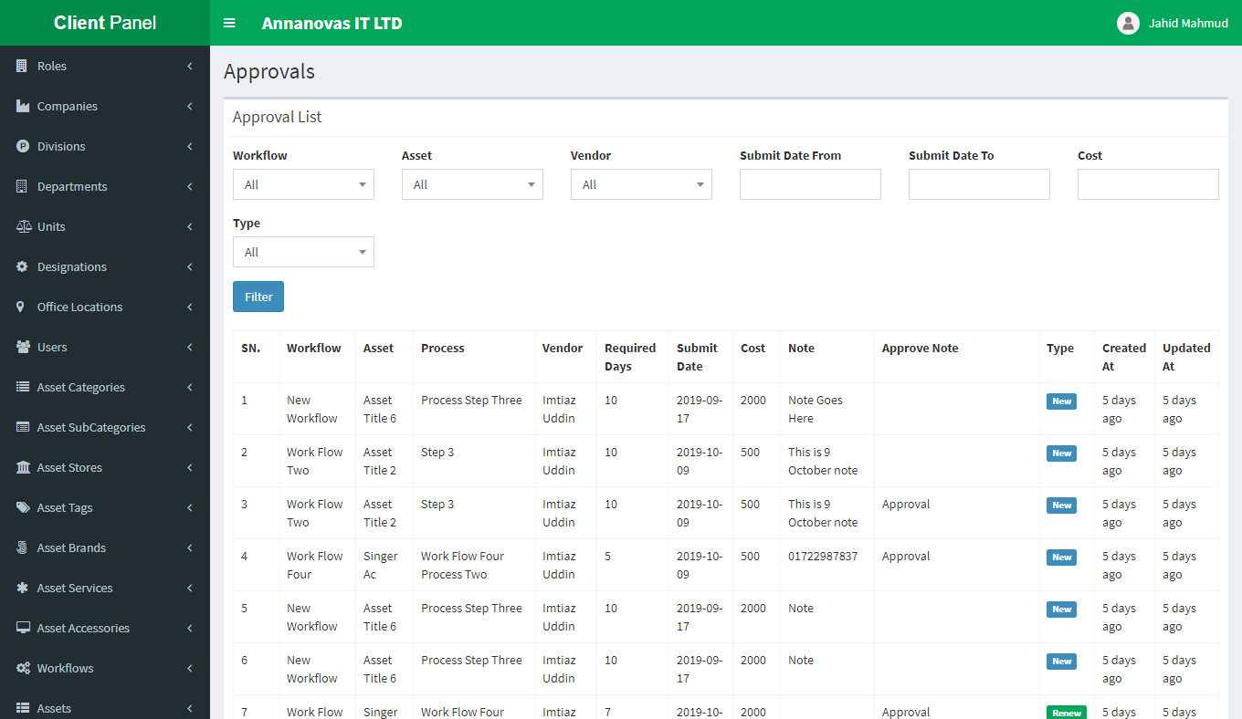By clicking this menu you can see all your approval assessment lists.
* From list you can see all approval list.

**20. Rejected List: Rejected List menu is responsible for viewing all assessment rejected lists.**

* 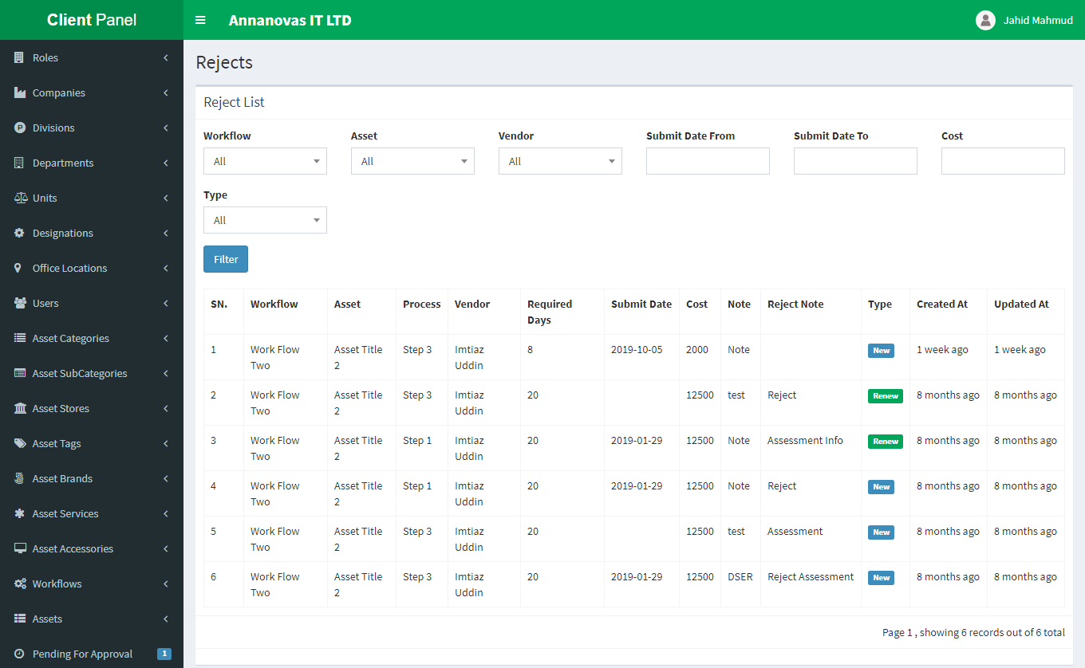By clicking this menu you can see all your rejected assessment lists.
* From list you can see all rejected lists.

**21. Assessment List: Assessment List menu is responsible for viewing all assessment approval or rejected lists as well as which user approved it which user rejected it from the timeline.**

* By clicking this menu you can see all your assessment lists.
* 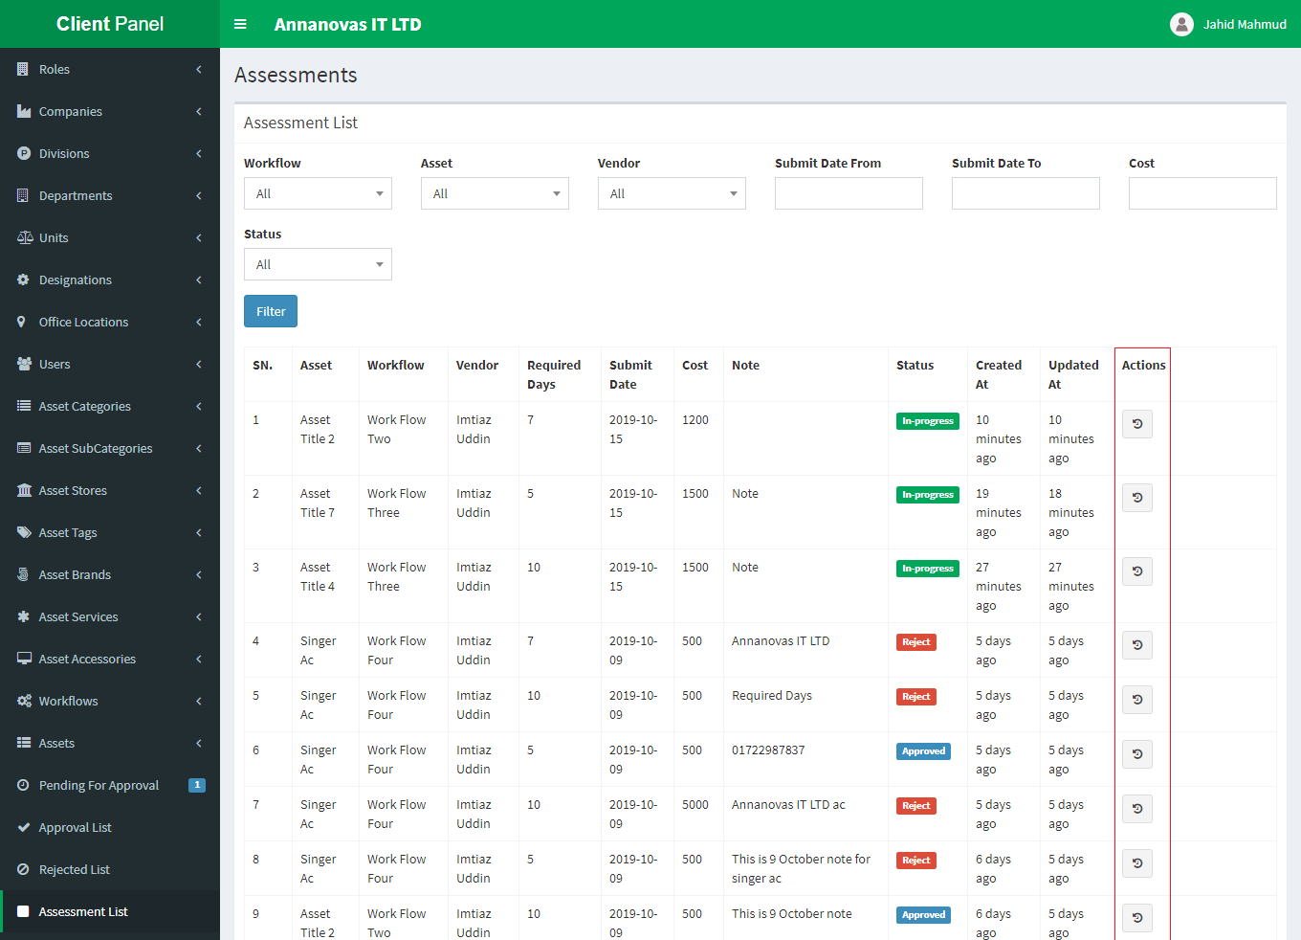From list you can see all approval or rejected lists.
* Now if you click the action link icon then you can see all details in the timeline.
* From the timeline table you see all details.

1. 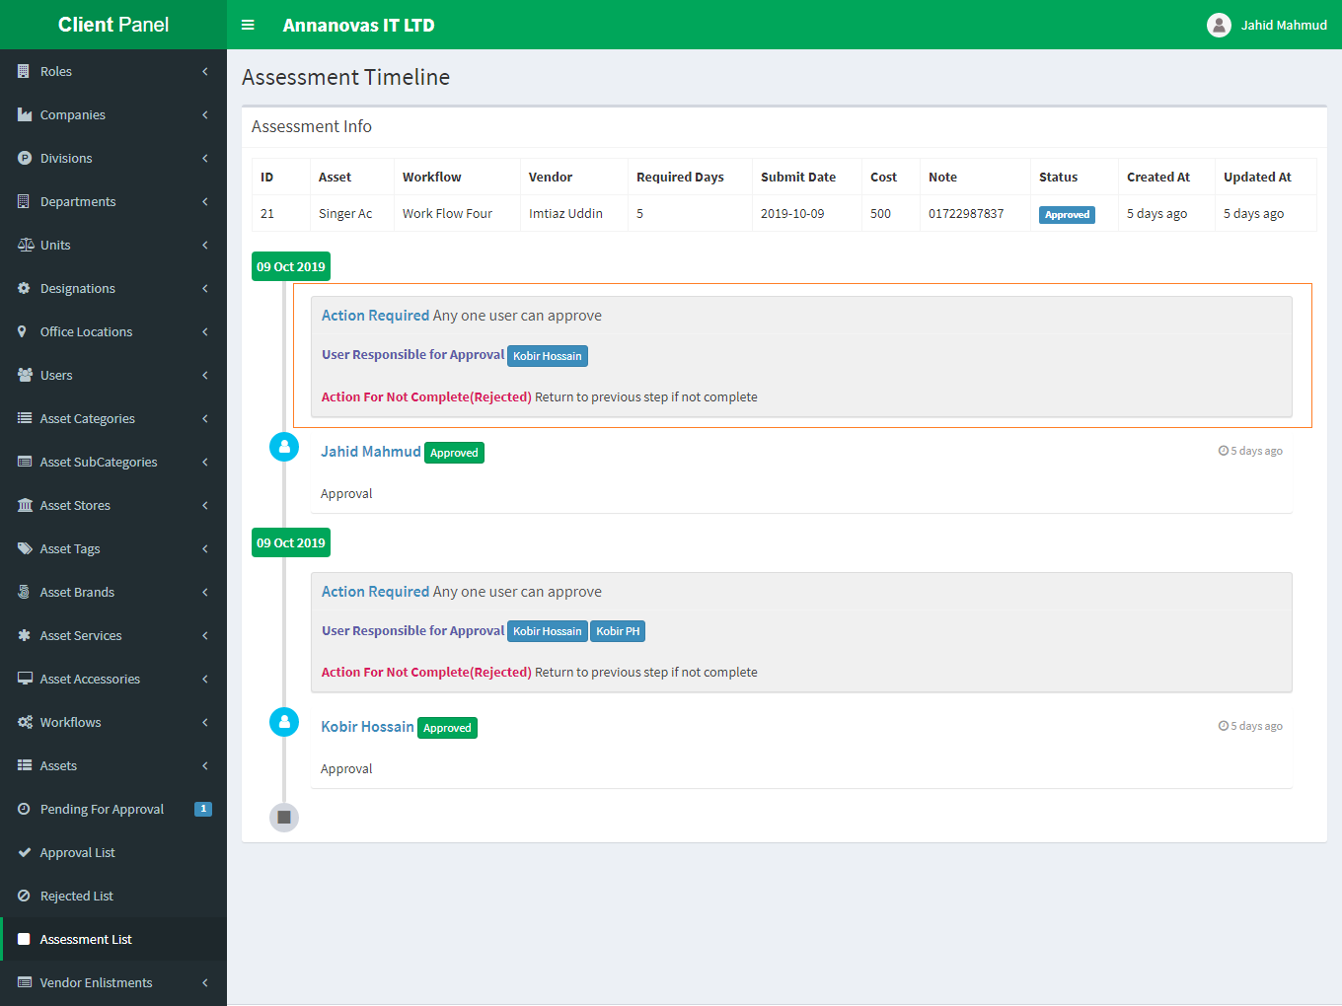**Vendor Enlistments: Vendor Enlistments menu is responsible for enlisting new vendor to repairing client defected assets.**

* 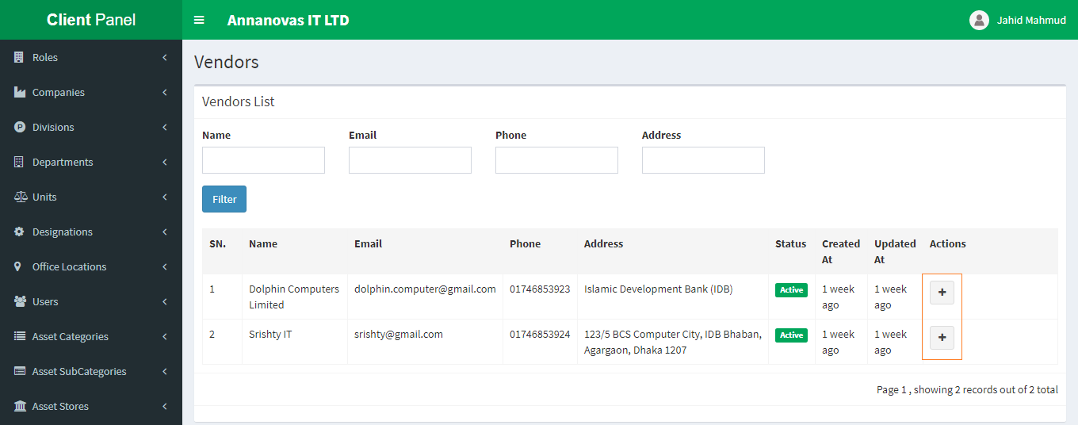 To create a new vendor enlistment please navigate to Vendor Enlistments  => New Enlistment
* Then you can see all Vendor list who registered by the application owner (Supper Admin).
* If you enlistment a vendor previously then can’t see this list.
* 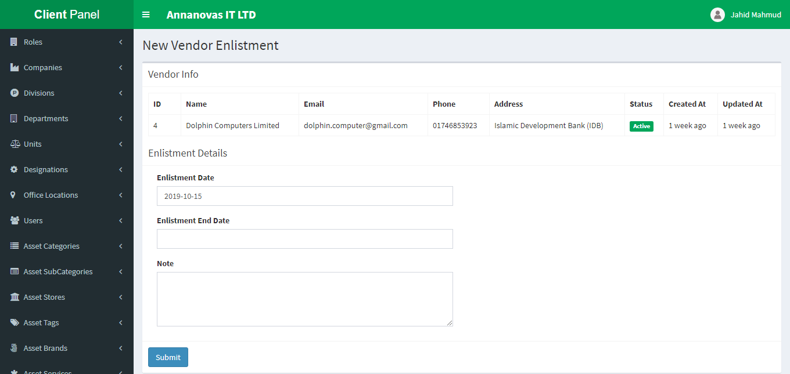To add or enlist click the plus icon marked above then a new page is opened
* 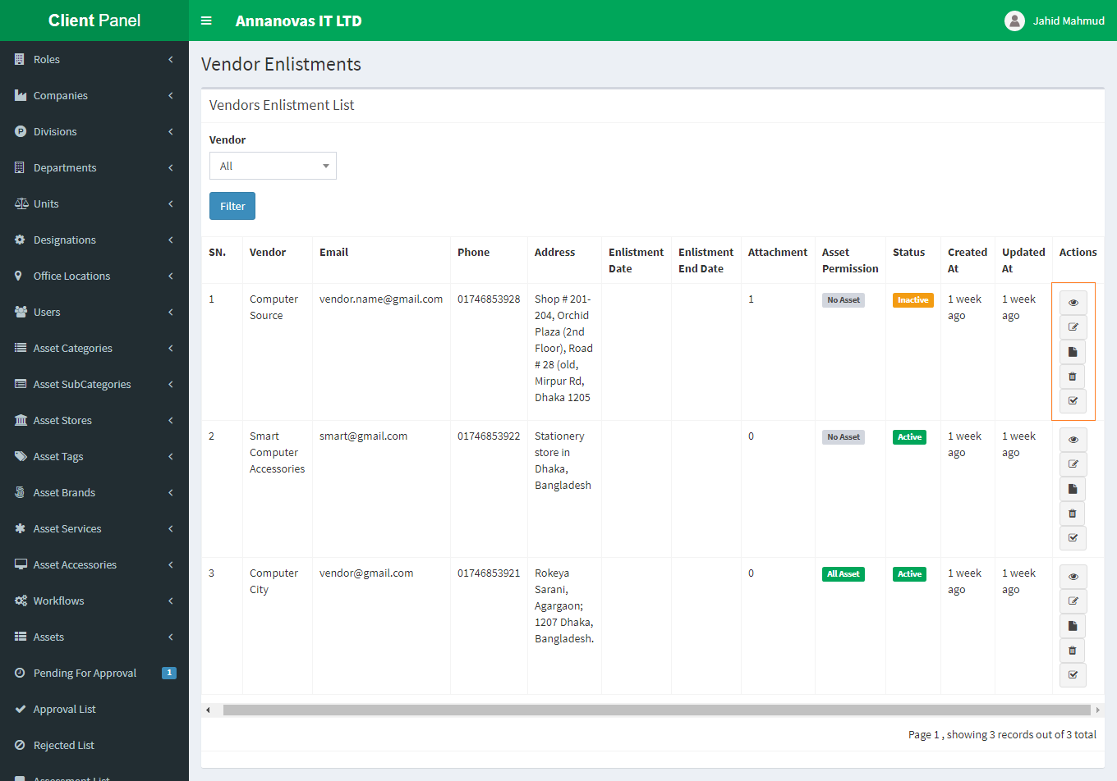After successfully create a new enlistment then you can see all enlisted vendor lists.
* vendor-enlistments-icon.pngFrom the above asset list there are lots of options along the actions column. From top to bottom

1. 1st icon(eye) for view the details
2. 2nd (edit) for edit the enlistment
3. 3rd (file) for file attachment
4. 4th (trash) for delete
5. 5th (square check) for asset permission type

To do any action you must have permission for this task otherwise you can’t.

View edit and delete as usual process so we can’t describe here.

* 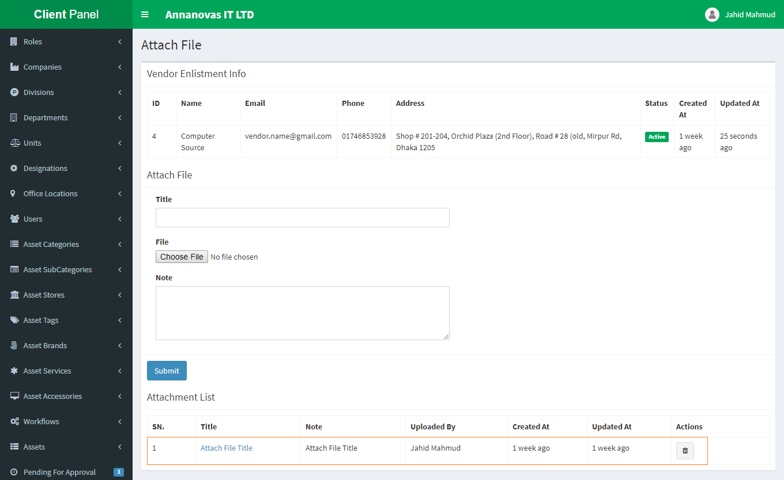For Attached any file click to the 3rd (file icon) then you can see
* From here you can attach file, title, and note.
* You can also see all attachment from Attachment List bellow.
* You can view attachment details by clicking title link.
* You delete previously attachment by clicking delete icon too.
* By clicking the 5th (square check) icon you can attach vendor asset permission type
* 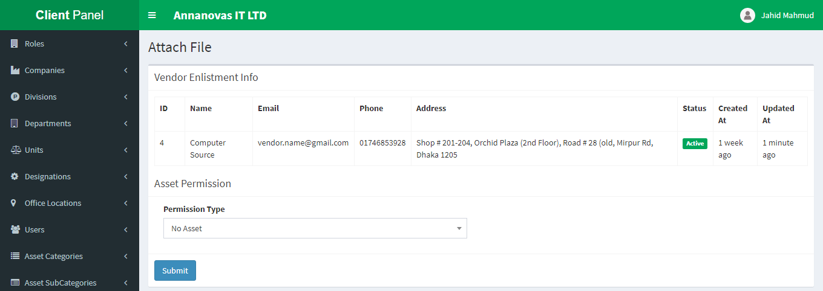There mainly three types of permission..

1. 1st => No Asset
2. 2nd => All Assets
3. 3rd => Exclusively Some Assets

* **1st =>** '**No Asset':** If select this option this vendor can’t access any assets.
* **2nd =>** '**All Assets':** If select this option this vendor can access any assets.
* **3rd => '** **Exclusively Some Assets ':** If select this option this vendor can access some assets which permitted in the assets list.
* **Note:** if the vendor status is inactive then vendor can’t access any asset too.